DEPARTMENT OF LAW
DR. AMBEDKAR COLLEGE, DEEKSHABHOOMI, NAGPUR
LEGAL AID CLINIC

NAME OF THE PROGRAM: | AWARENESS TALK ON THE POCSO ACT AND CELEBRATION OF WORLD POPULATION DAY
DAY: | 11 JULY 2022
TIME: | 11.00 AM –1.30 PM
NAME OF CELL: LEGAL AID CLINIC

PROGRAM COORDINATOR: DR. PRATIMA LOKHANDE

MEMBERS: Mrs. VAISHALI SUKHDEVE
Miss. SARIKA KAMDI

STUDENTS: 60

REPORT ON
AWARENESS TALK ON THE POCSO ACT AND CELEBRATION OF WORLD POPULATION DAY
Child sexual abuse is a major concern that is increasing day by day in India and to fight child sexual abuse, it is important that we all take responsibility in our own various ways to combat the menace. The country is experiencing frequent incidences of violations against children. In some incidents children are perpetrators and sometimes they are victimized by the people of their own surroundings. Protection of Children from sexual offences (POCSO) Act, 2012 in order to effectively address the heinous crimes of sexual abuse and sexual exploitation of children through less ambiguous and more stringent legal provisions.
The Legal Aid Clinic of Department of Law, Dr. Ambedkar College, Deekshabhoomi, Nagpur in collaboration with District Legal Services Authority organized the “AWARENESS TALK ON THE POCSO ACT”.
The main objective of the Legal Aid Clinic is to create awareness on ‘POCSO Act 2012’ to law students and teaching students to understand the special provisions of legislations and helping them to stand up for the safety of children. It was held on 11th July, 2022 at the College Seminar Hall.
The event began with ceremonial lighting of the candle and garlanding the portraits of Tathagat Guatam Buddha and Param poojya Dr. Babasaheb Ambedkar and the felicitation of the guests with sapling.
The welcome speech was given by Principal of College Dr. B. A. Mehere Thereafter Dr. Pratima Lokhande, coordinator of Legal Aid Clinic has given overview of activities of Legal Aid clinic.
Shree Jaydeep Pandey, secretary DLSA delivered a lecture among the students and sensitized the students on the very important topic of sexual abuse of children by citing live examples. He started with mentioning the offences given under IPC and then focussed on the detailed provisions of POCSO ACT. He mentioned about the lacunae in IPC like the problem of pornography is not mentioned in it and so the need to have new legislation which is Gender neutral in the form of POCSO. He discussed various kinds of offences mentioned in the Act regarding sexual abuse starting from sexual harassment, sexual assault and penetrative sexual assault and its aggravated form. He also discussed the penal provisions of such offences and made the students aware of the same.

CELEBRATION OF WORLD POPULATION DAY

Adv. Rajendra Rathi Sir very well explained the urgency and importance of population issues. He said there is a need to pay attention towards issues like importance of family planning towards the increasing population, gender equality, maternal and baby health, poverty, human rights, right to health, girl child education etc. He said there is a urgent need to make sure the easy access of reproductive health services everywhere as part the basic primary health for each couple.
that legal profession is a profession of service and not of business and encouraged the students to actively participate in dealing with the problems of over population and how a law student can contribute in problem solving.

Dr. S.P. Kalamdhad, Ms. Shilpa Rathod, Ms. Sarkia Kamdi attended the program.
Vaishali Sukhdeve, accorded the vote of gratitude at the end of this enlightening session.

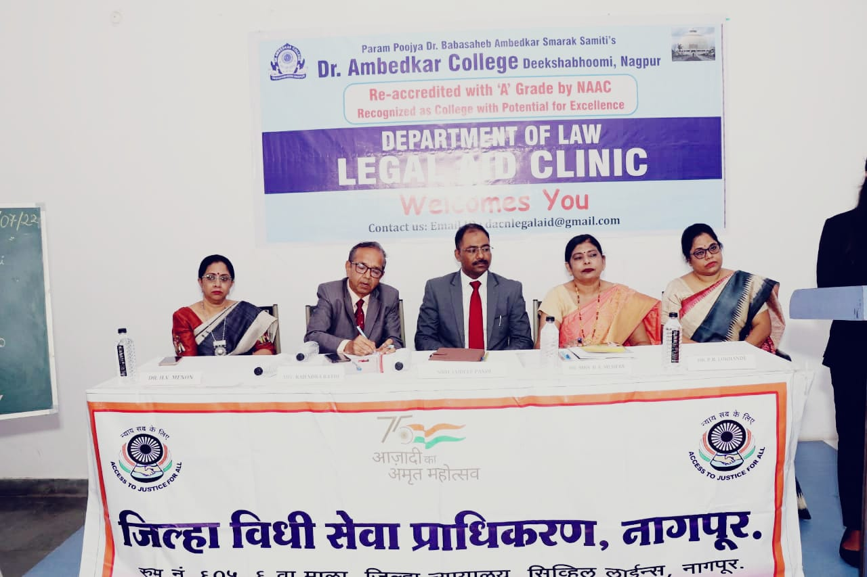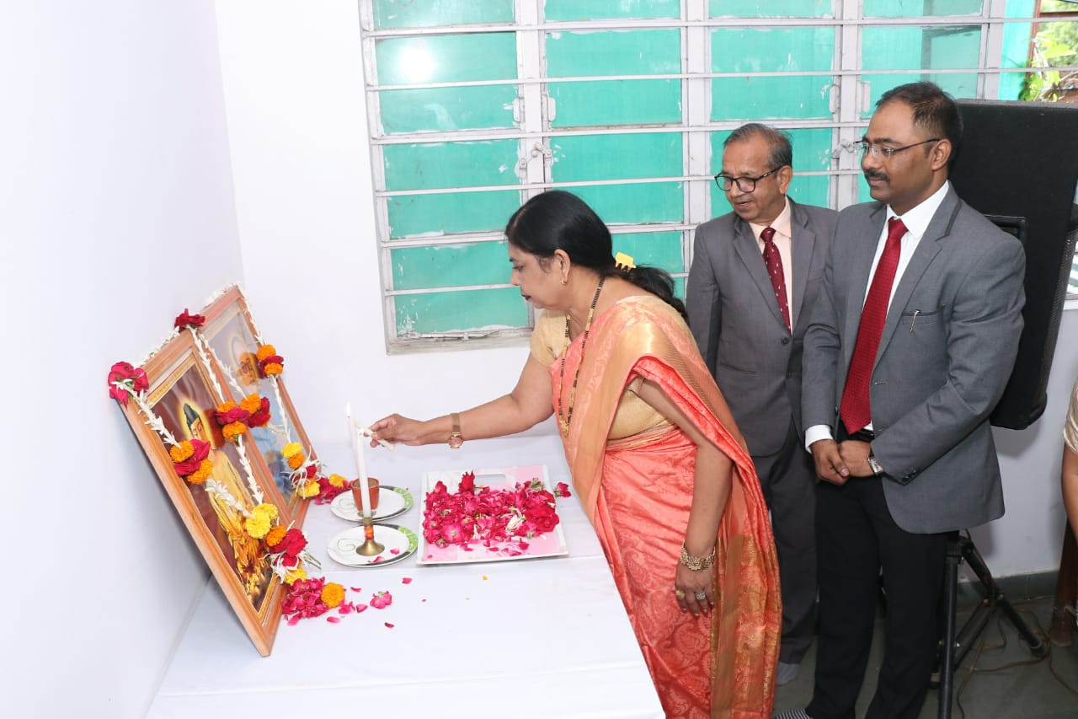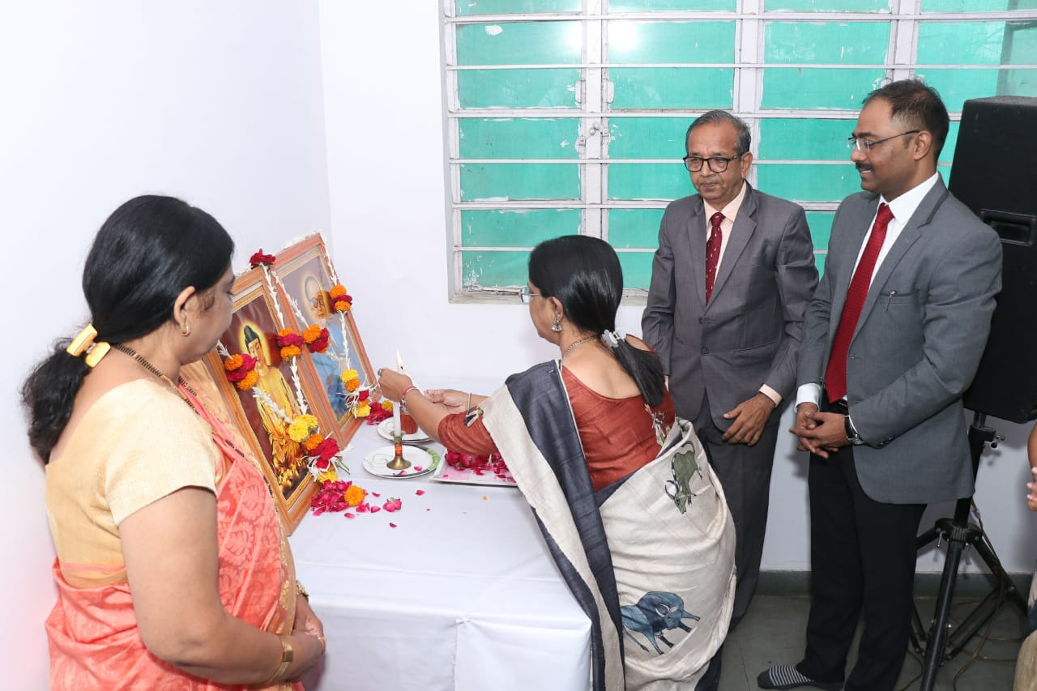
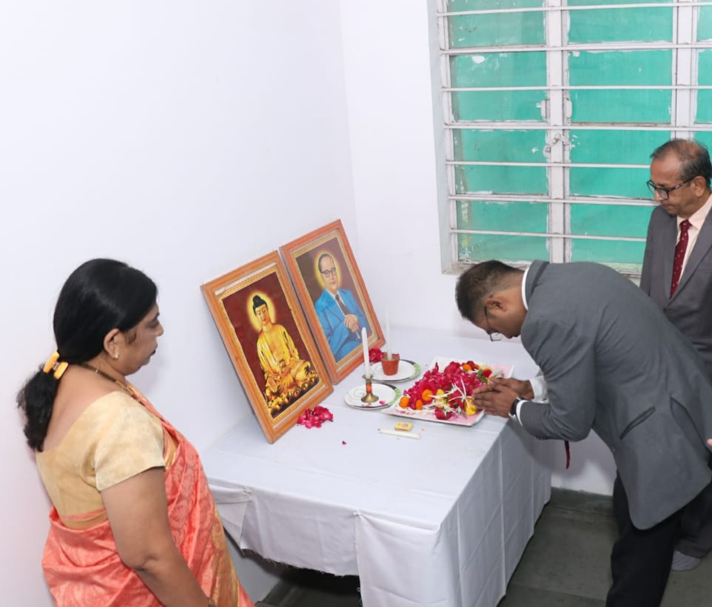
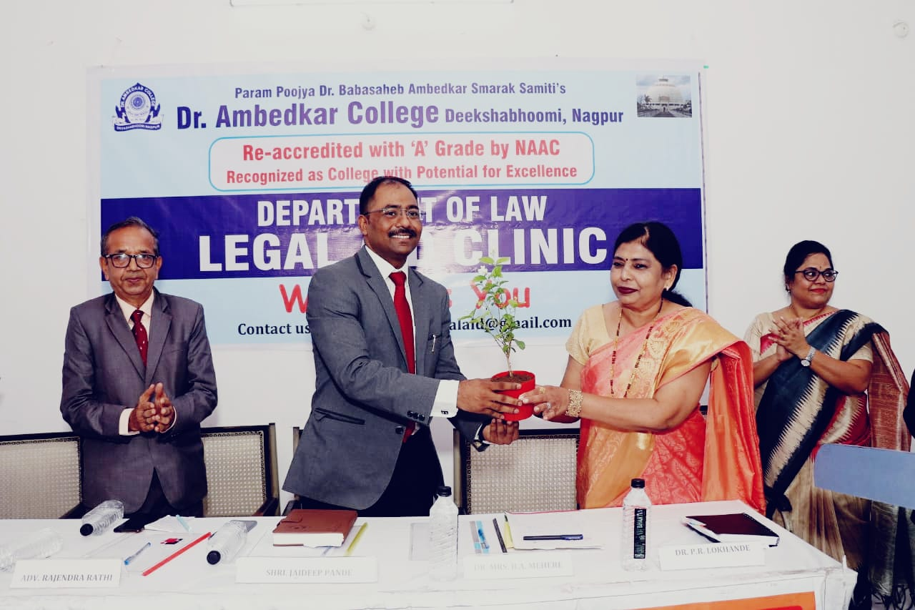
Floral Welcome of Shree Jaydeep Pandey, secretary DLSA by Principal B.A.Mehere
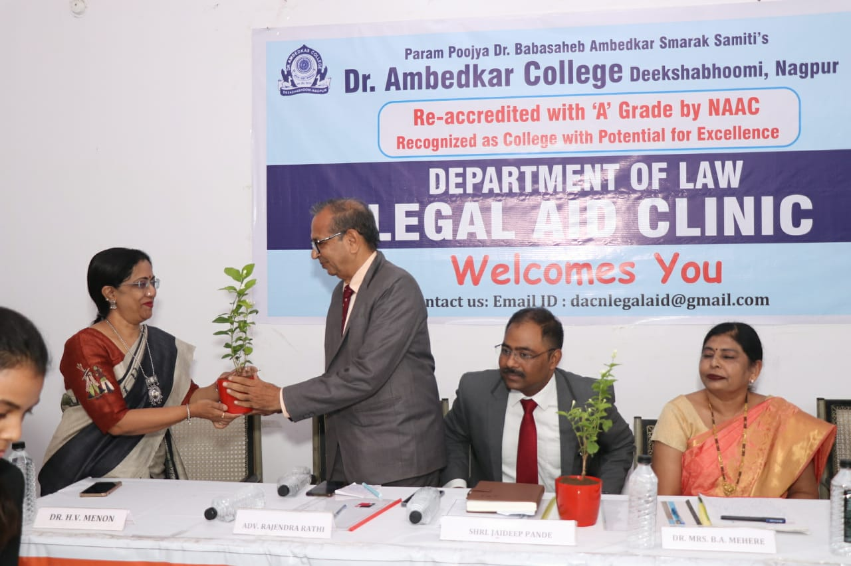
Floral Welcome of Adv. Rajendra Rathi by HOD Dr. H.V.Menon

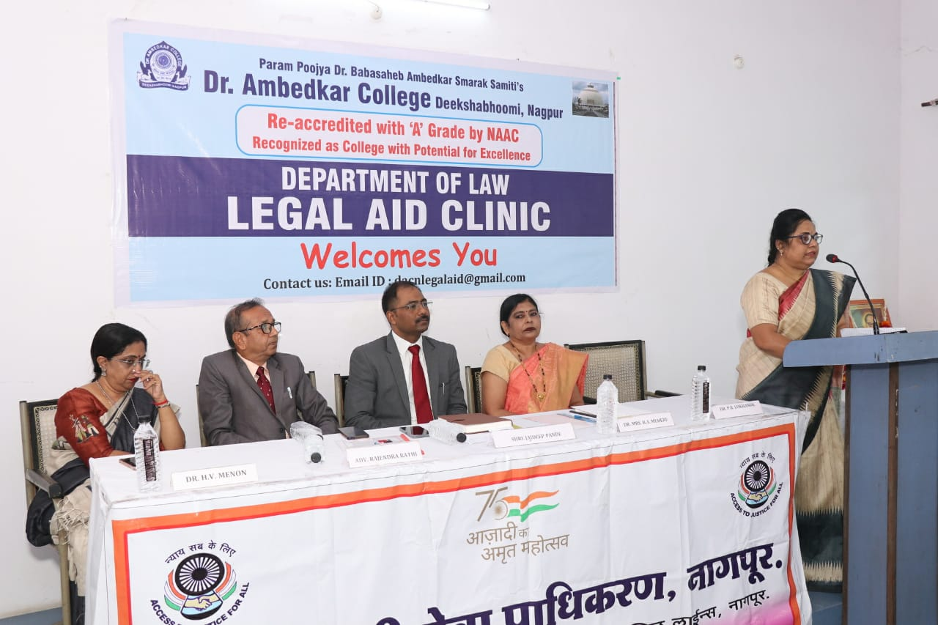
Dr. Pratima Lokhande giving overview of Legal Aid Clinic
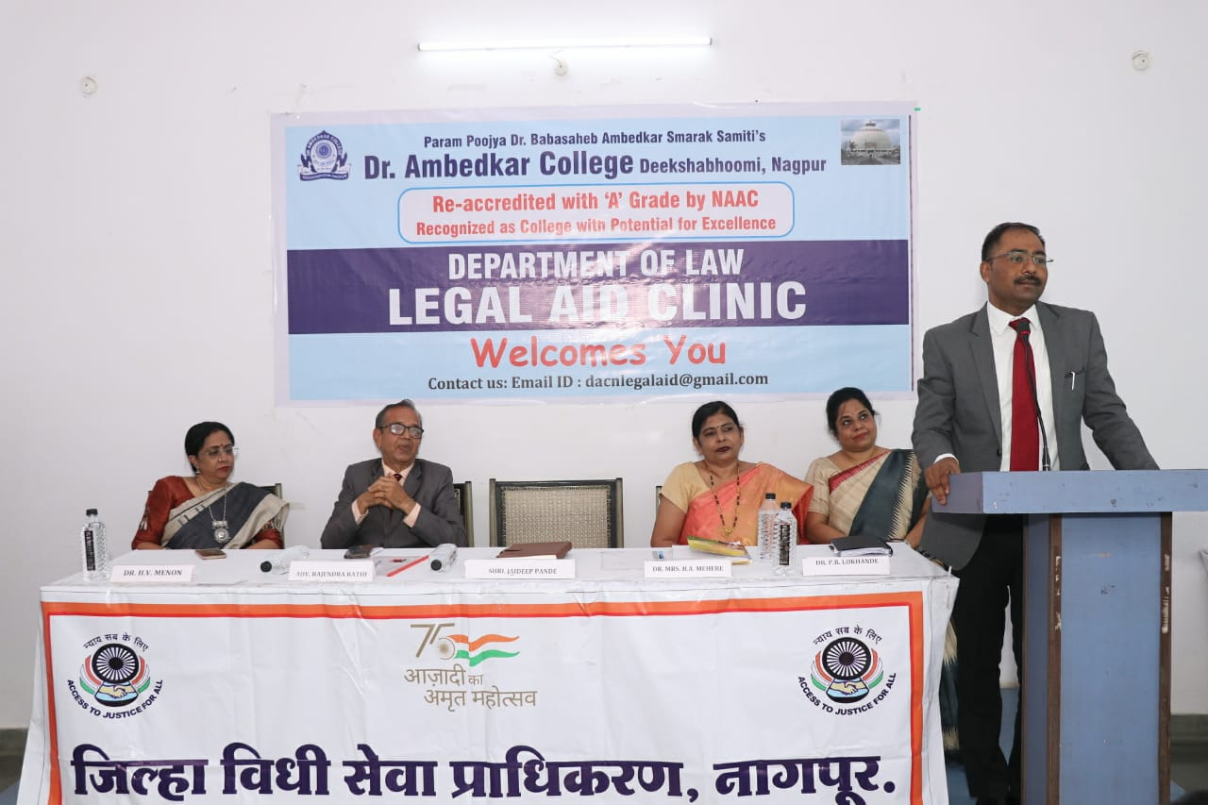
Shree Jaydeep Pandey, secretary DLSA addressing the students
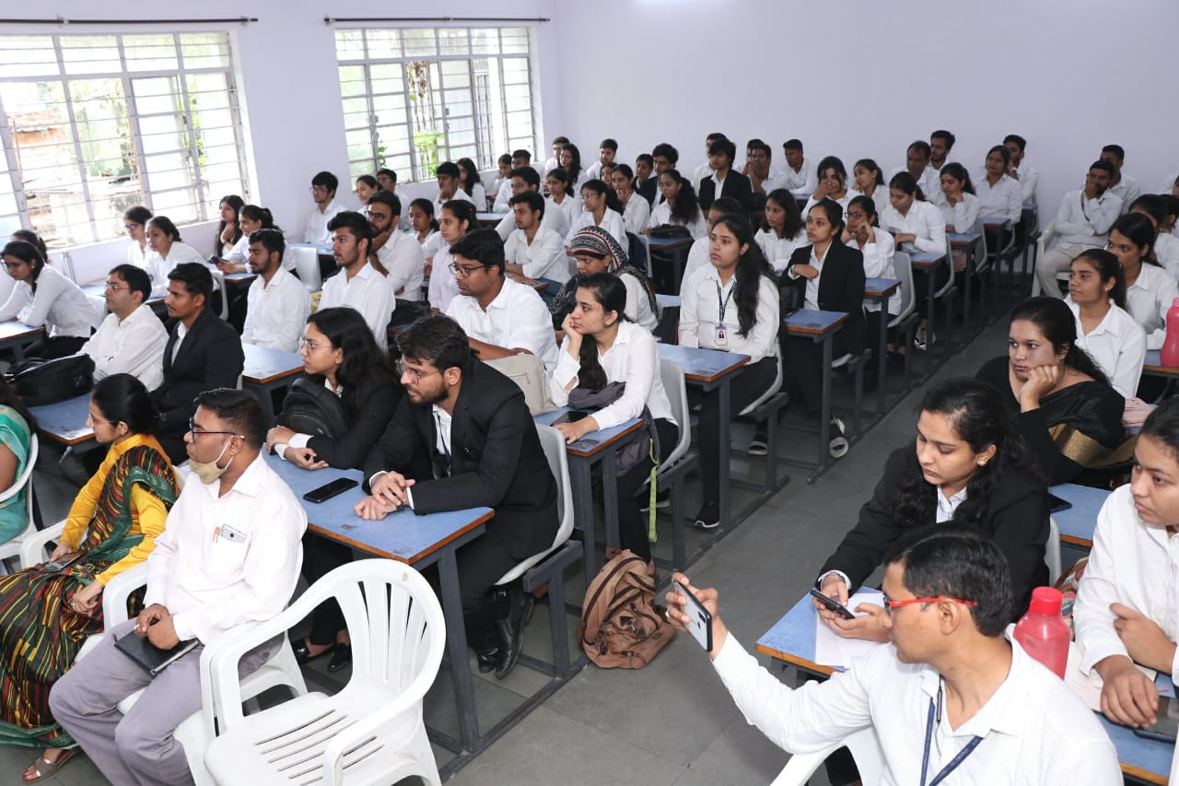

Glimpses of Visit To LEGAL AID CLINIC
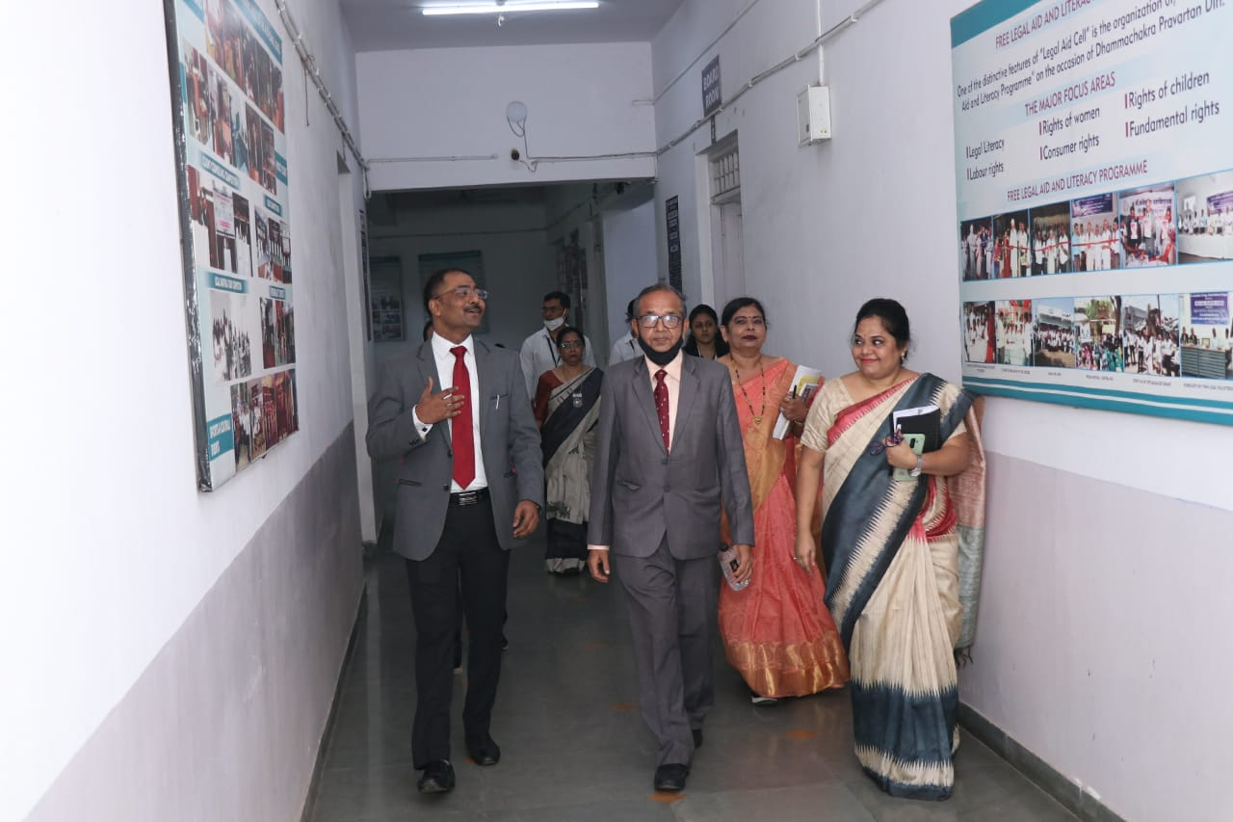
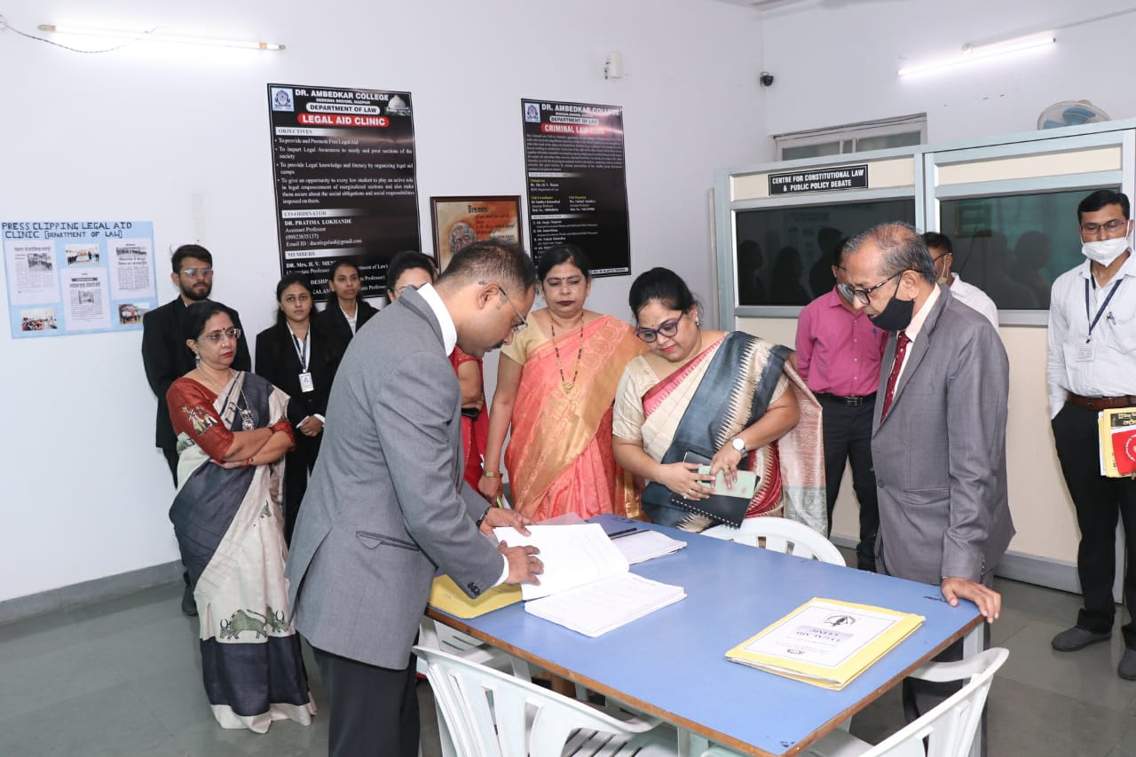
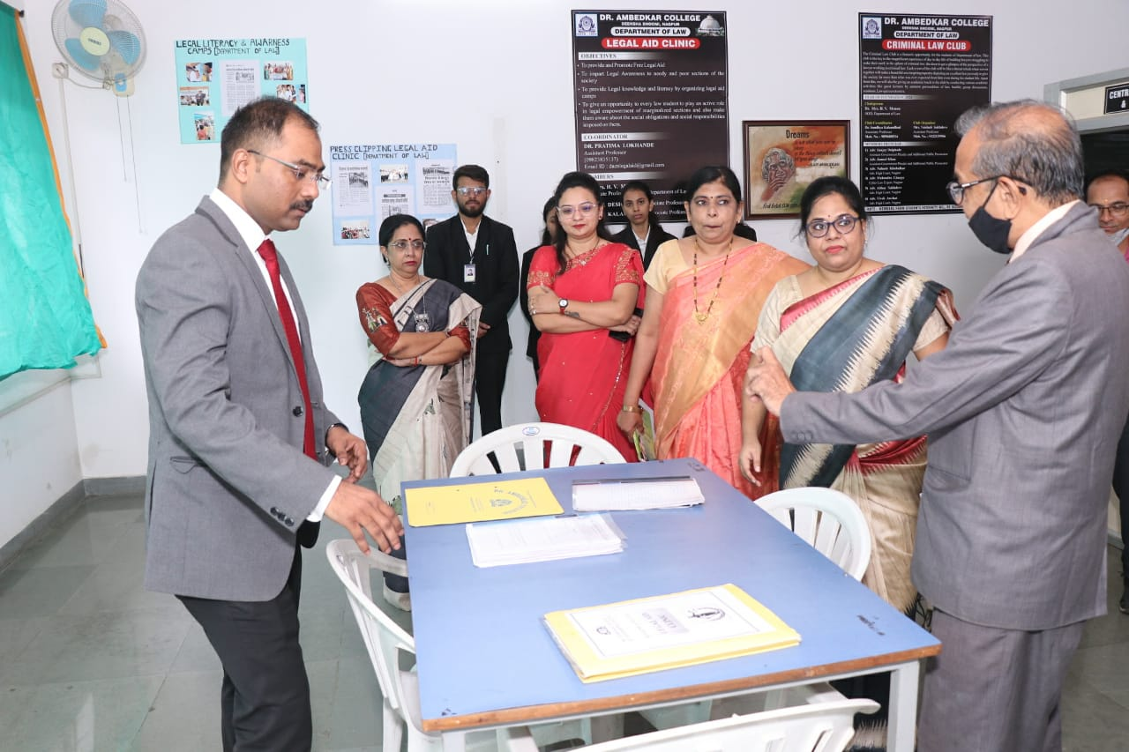

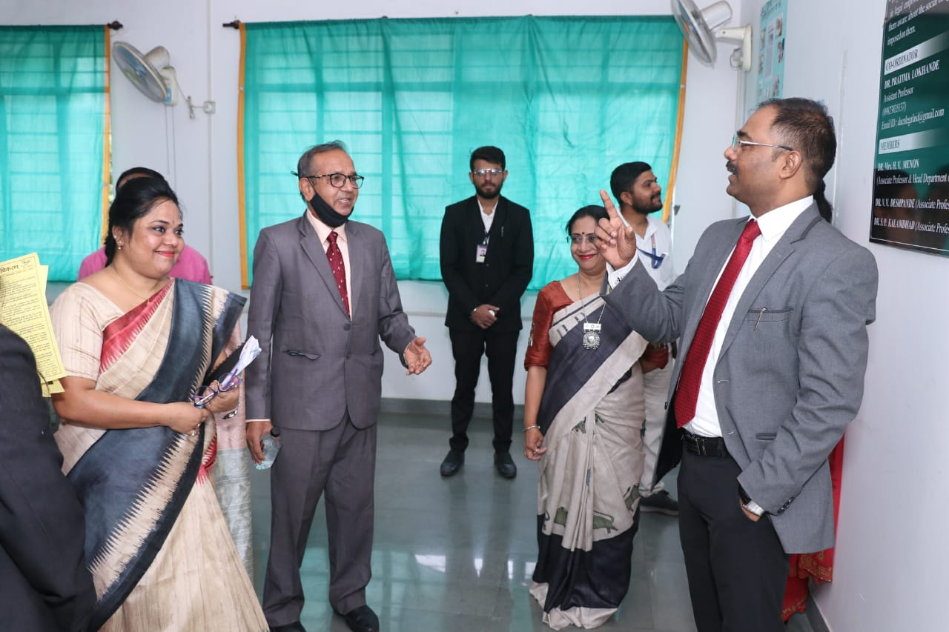
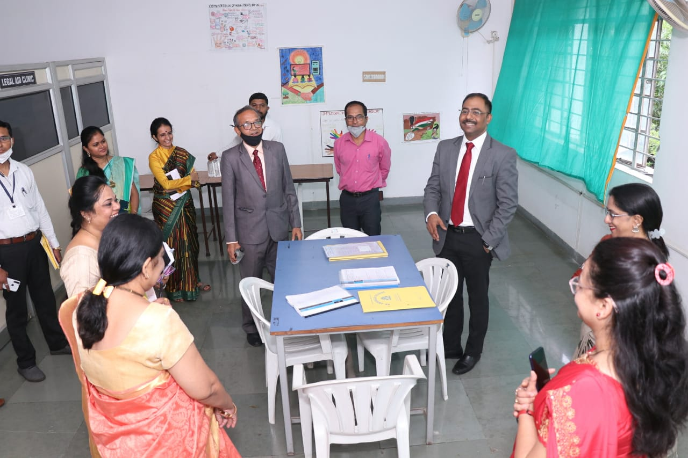

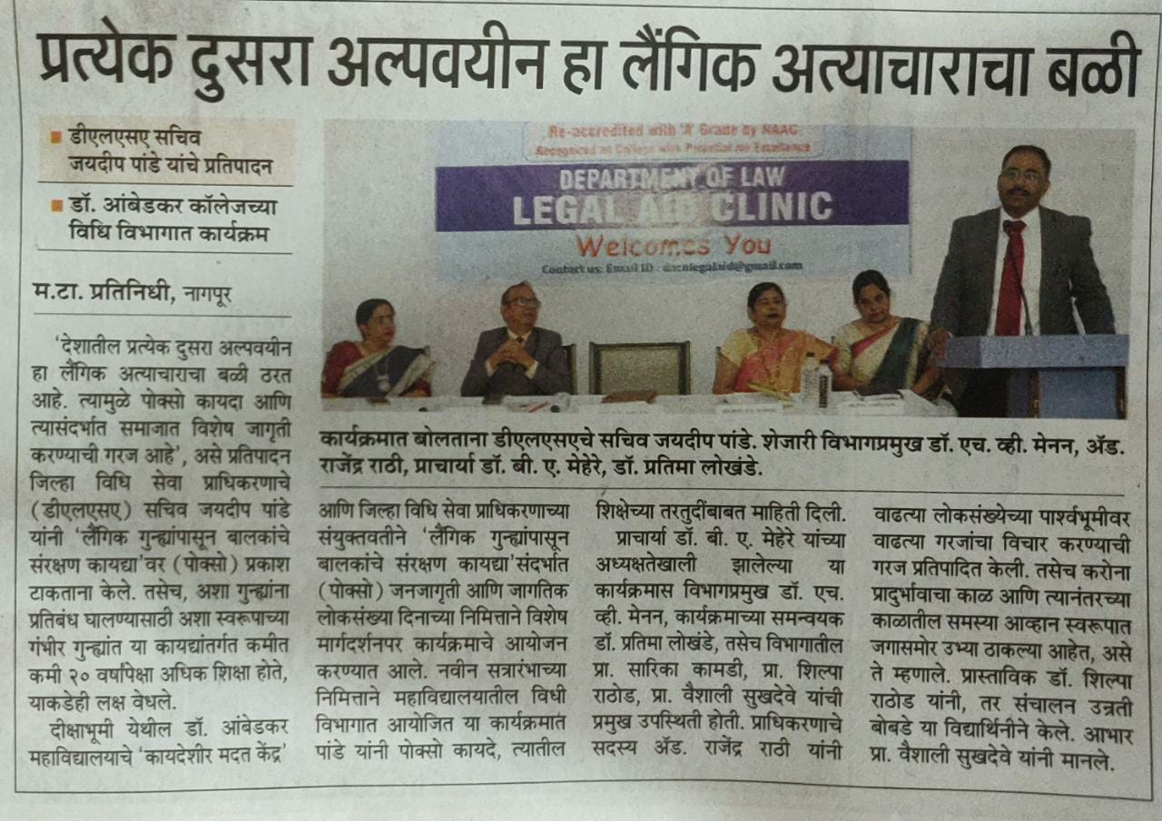
Newspaper Coverage

DR. AMBEDKAR COLLEGE, DEEKSHA BHOOMI, NAGPUR

Date: 16th September 2022
Name of the Programme: Anti- Ragging Awareness Program & Awareness
Programme on “Victims of Drug abuse: An eradication of Drug Menace”
Resource Persons: Hon’ble Shri Anilkumar Sharma
Adv. Smita Deshpande
Organised by: Legal Aid Clinic
Anti-ragging Cell
Name of Program Co-ordinators: 1. Dr. Pratima Lokhande
2. Dr. Sandhya Kalamdhad
Name of Members : 1. Dr. Priti Singh
2. Ms. Shilpa Rathod
3. Mrs. Vaishali Sukhdeve
4. Ms. Sarika Kamdi
Number of Attendees: Around 223
Name of Venue: College Auditorium Dr. Ambedkar College Deeksha Bhoomi, Nagpur
NOTICE
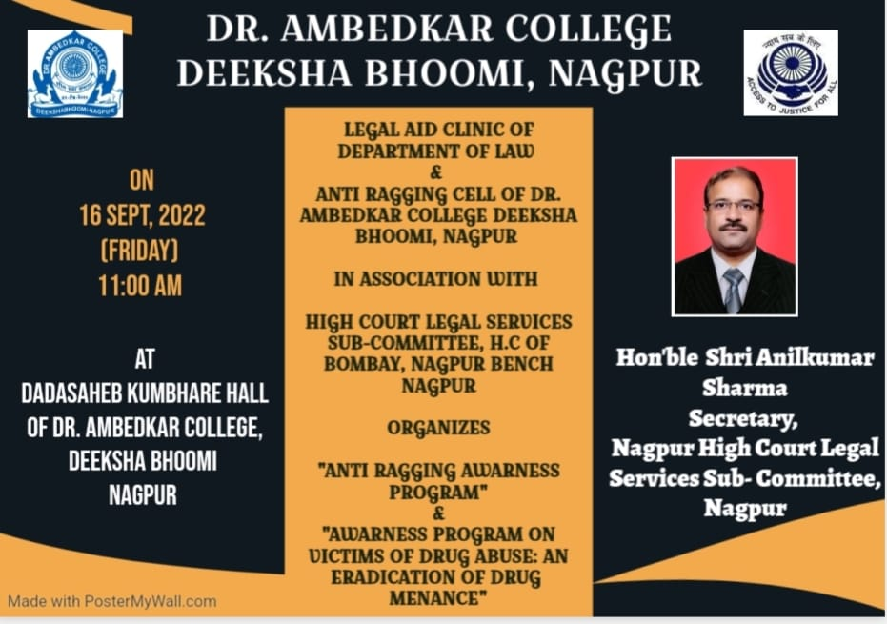

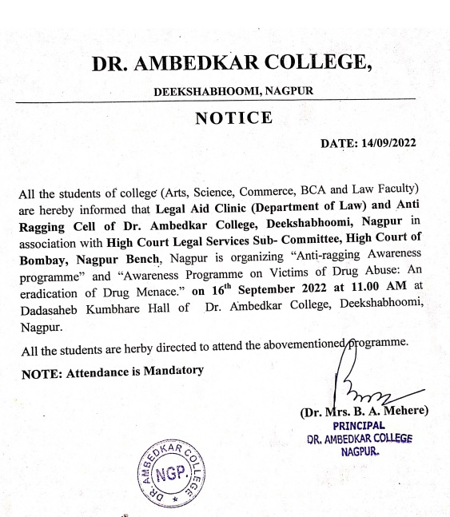

REPORT ON AWARNESS PROGRAM

The Legal Aid Clinic of the Department of Law and Anti Ragging Cell of Dr. Ambedkar College, Deeksha bhoomi Nagpur, in collaboration with Nagpur High Court Legal Services Subcommittee, Nagpur has organised an awareness Program on 7th Sept 2022 for the students of various disciplines Art, Science, Commerce, and Law.
Around 200 attendees were present in the program. Hon’ble Shri Anilkumar Sharma, District Session Judge and Secretory of Nagpur High Court Legal Services Subcommittee, Nagpur and Adv. Mrs Smita Deshpande Practicing Advocate in District Court and High Court invited as Chief guest and Guest of Honour.
The program commenced with the lamp lighting ceremony by the hand of hon’ble guests of the Programme which was followed by the welcome address by Dr. Bhoomi Mehere Principal of the college to the well acclaimed Judges, the faculty members of the departments, treasured invitees and the participants. Dr. Hema Menon gave brief information regarding department of law. Dr. Pratima Lokhande gave the overview of the Legal Aid Clinic of Department of law. Dr. Priti Singh has briefed about the Anti-Ragging cell of the College.

Adv. Smita Deshpande enlightened the audience on the topic of Anti-ragging laws. She has provided the statistical record with the courts dealing with Anti-ragging cases. Further she elaborative discussed regarding the provision of the law on Anti-Ragging. She empathetically mentioned that there is a psychological element involved in the cases of ragging.
Hon’ble Shri Anilkumar Sharma delivered the Presidential remark and shared the information regarding the provisions of anti-ragging laws. He elaborately convenience the students regarding the repercussion of the ragging in college. He further dealt with the topic on “Victims of Drug Abuse: Eradication of the Drug menace”. He has shared the statistical record of the Drug abuser and briefed regarding the various terminology of Drug abuse, drug victim and drug pedlars. He enlightened the audience with the different laws in the domain of Drug abuse.
The hon’ble guests overwhelmed by knowing that our college has no case of Ragging till present date and for that they have congratulated the college.
The Programme was conducted by Ms. Shilpa Rathod under the guidance & supervision of Dr. Pratima Lokhande, Associate Professor and Co-ordinator of Legal Aid Clinic, Department of law.
The event concluded with vote of thanks proposed by Mrs. Vaishali Sukhdeve to the jury members and also to everyone who was present to witness the event.

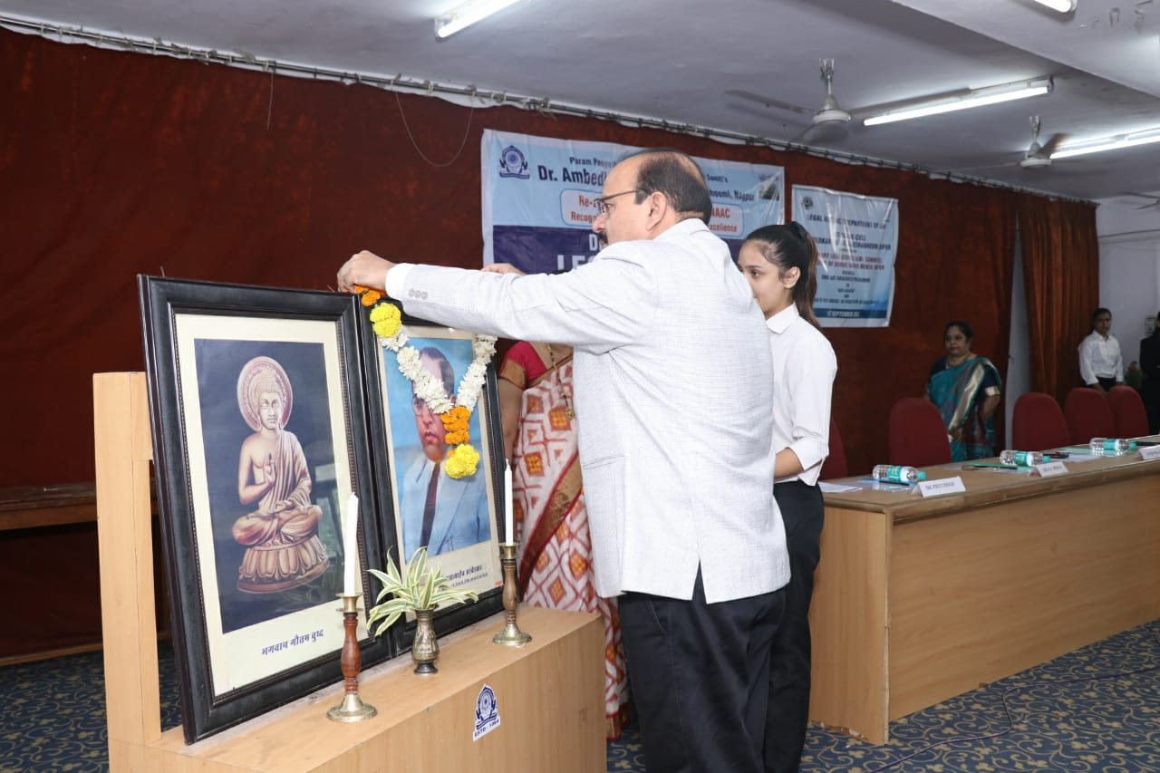
(Hon’ble Dignitaries lighting the lamp and invoking the Blessing of Tahagat Bhagwan Gautam Bhuddha and Parampoojya Dr. Babasaheb Ambedkar)

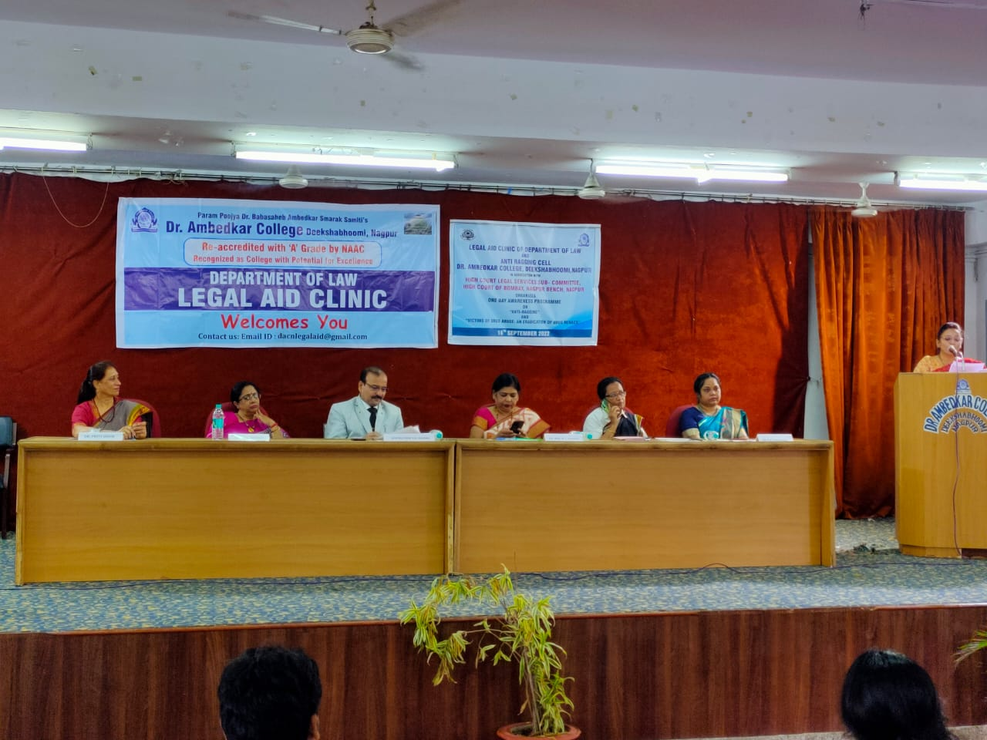
(Dignitaries on the Dias) 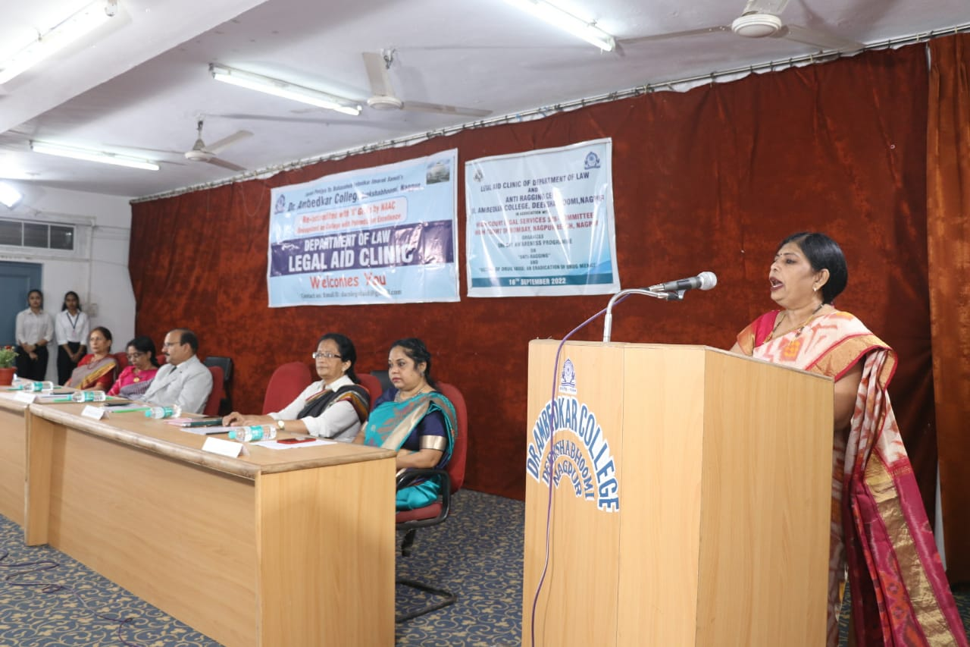
(Dr. Bhoomi Mehre, Principal of the College giving the welcome address)
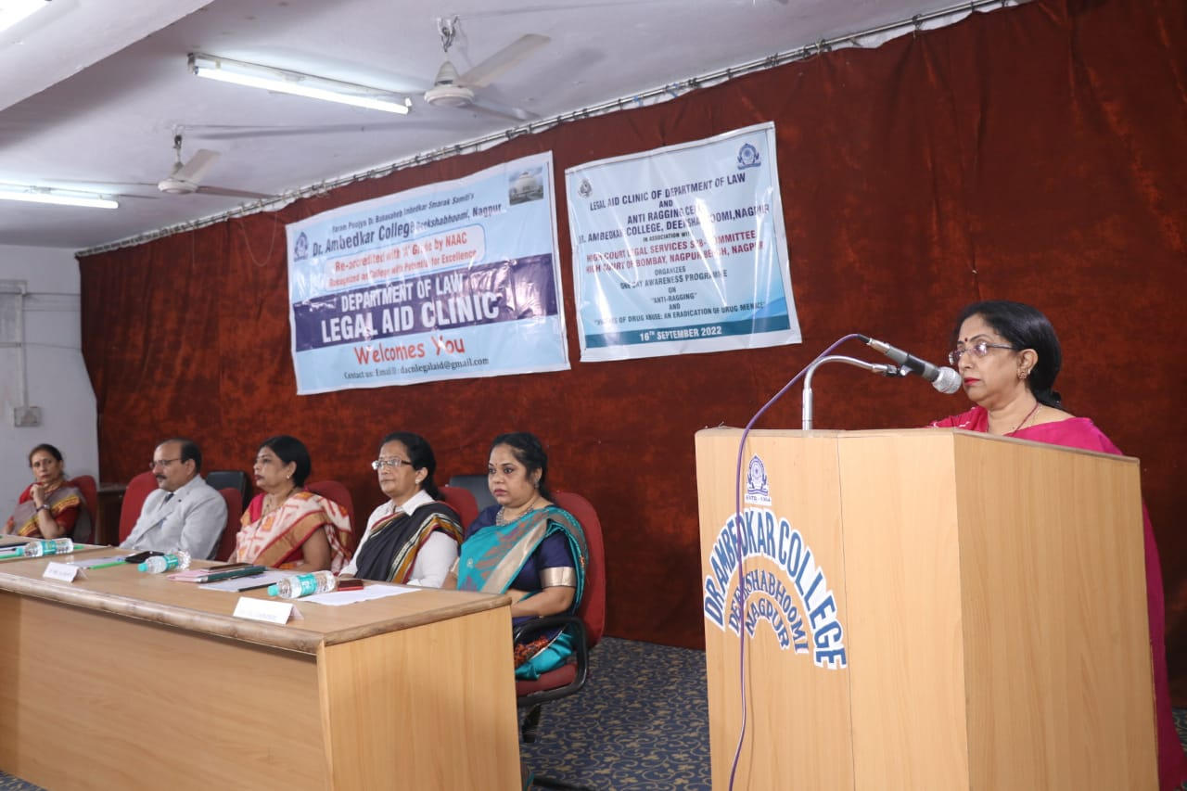
(Dr. H.V. Menon, Head Department of Law giving the brief introduction about Department of Law)

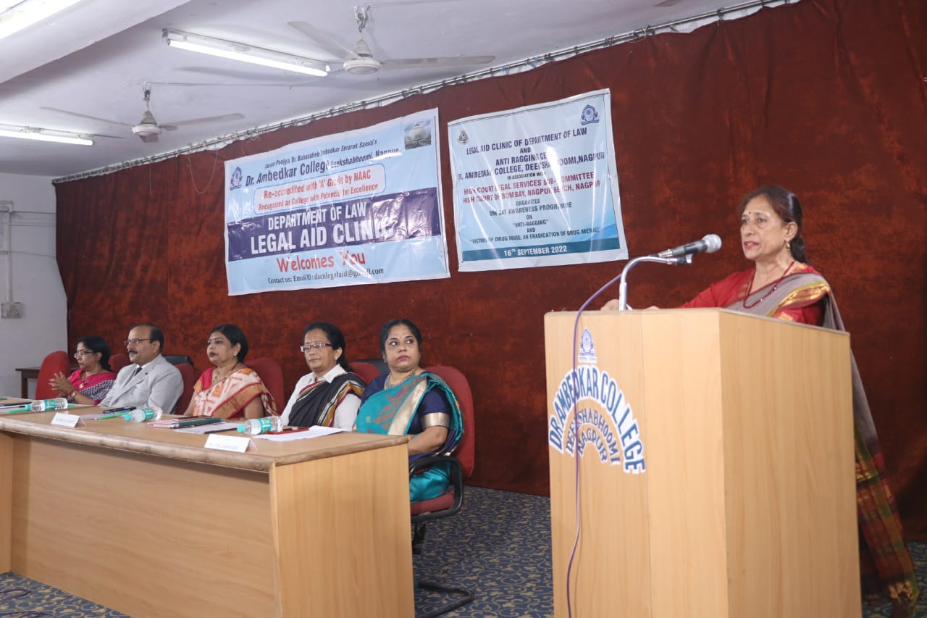
(Dr. Priti Sing Member of Anti Ragging Cell briefing about the work of Anti Ragging Cell)

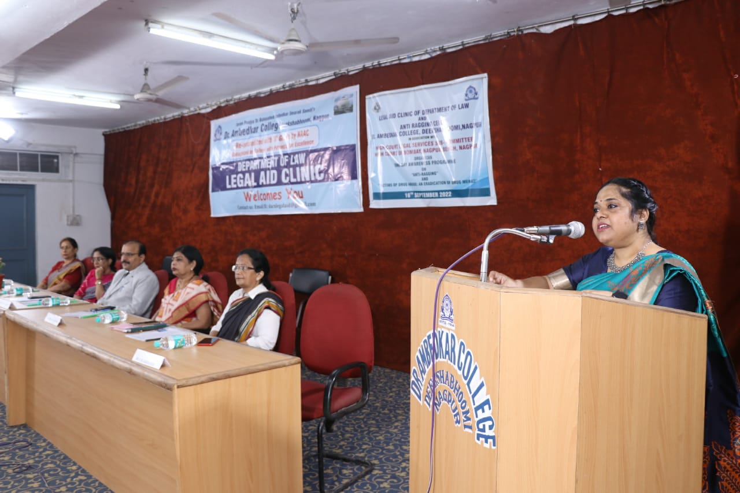
(Dr. P.R. Lokhande giving an overview of Legal Aid Clinic of Department of Law)
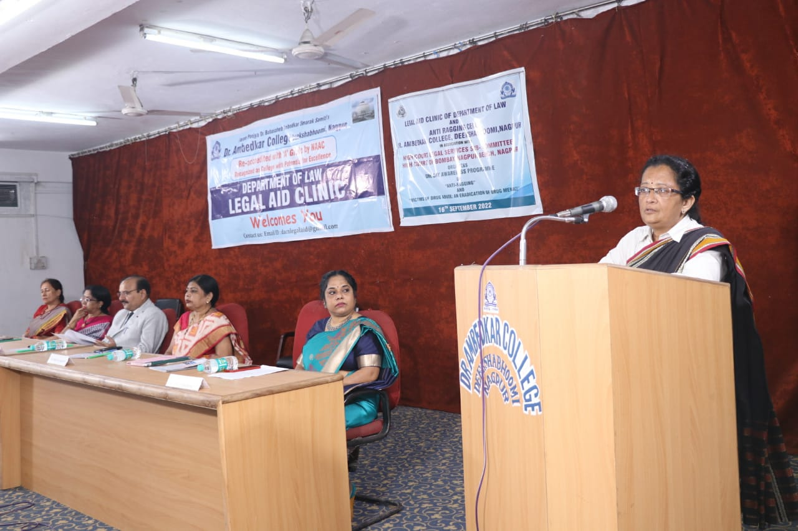
(Adv. Smita Deshpande delivering the brief provisions of the Ant-Ragging Law)

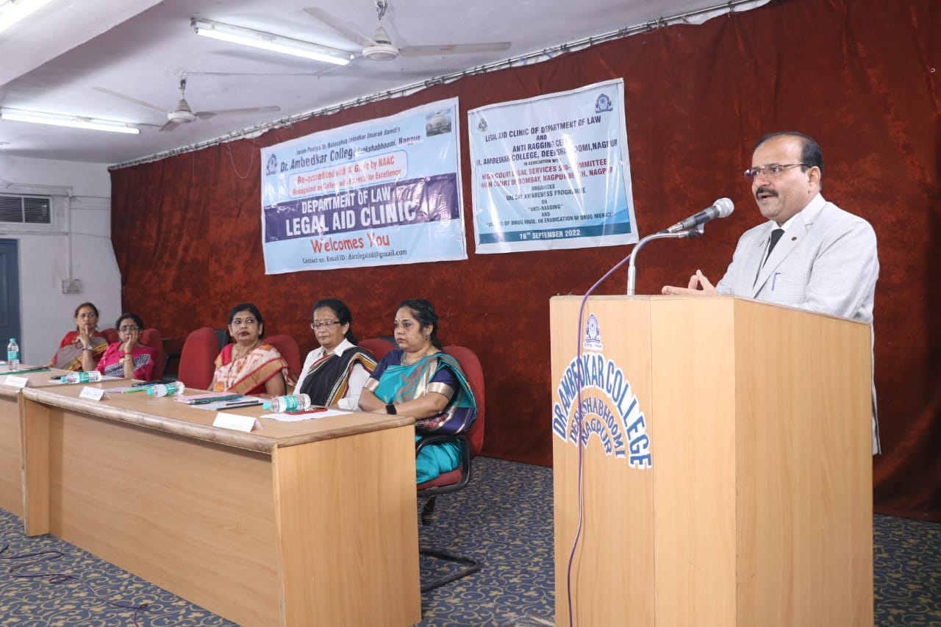
(Hon’ble Shri Anil Kumar Sharma giving the Presidential Remark)

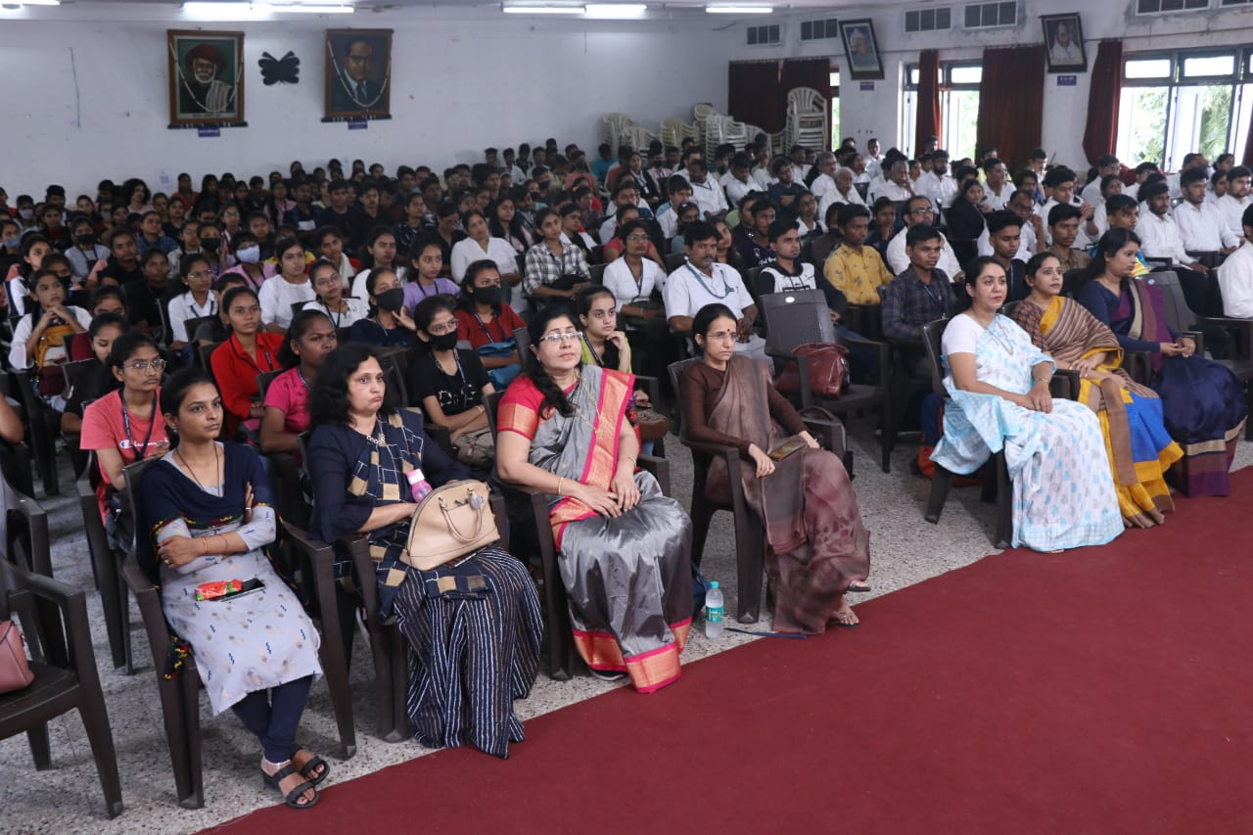
(Audience Present at the Awareness Programme)
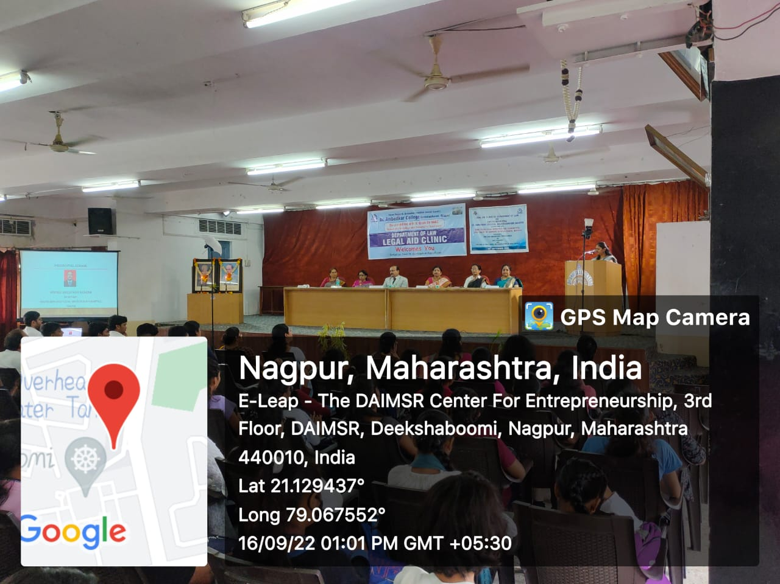
(Vote of Thanks by Mrs. Vaishali Sukhdeve, Assistant Professor Department of Law)

DR. AMBEDKAR COLLEGE, DEEKSHA BHOOMI, NAGPUR
DEPARTMENT OF LAW

Date: 15th September 2022
Name of the Programme: GUEST LECTURE ON HIGHER EDICATION
AND CAREER PROSPECTS ABROAD

Resource Persons: Mr. Abhishek Nath

Organised by: Legal Aid Clinic

Name of Program Co-ordinator: Dr. Pratima Lokhande

Name of Members: 1. Ms. Shilpa Rathod
2. Mrs. Vaishali Sukhdeve
3. Ms. Sarika Kamdi

Number of Attendees: 59 Participants
Name of Venue: Seminar Room, Department of Law
Dr. Ambedkar College Deeksha Bhoomi, Nagpur

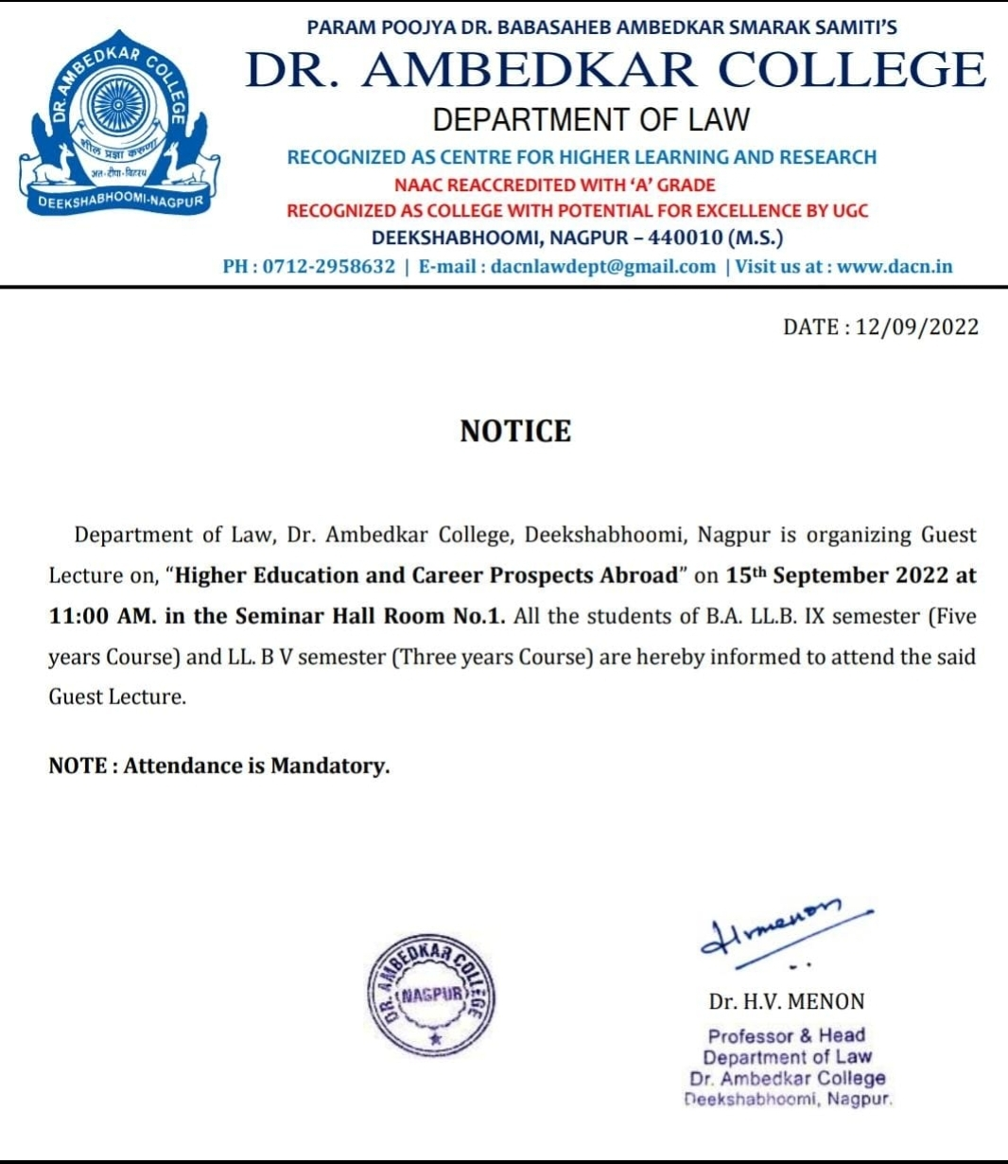

REPORT
ON
GUEST LECTURE ON HIGHER EDICATION AND CAREER PROSPECTS ABROAD

A Guest Lecture in Department of Law, Dr. Ambedkar College was held on 15th September 2022 by Mr. Abhishek Nath, Senior Counsellor at Global Reach Institute and educational consultant in Seminar Hall. He emphasized on how to prepare for studying abroad like Europe, America and Australia. If students are applying for a graduate-level degree, especially a master’s programs, doctoral programs, awarding fellowship etc.
Mr. Abhishek Nath explained various global career opportunities and talked about quality of education abroad. He pointed out that university abroad helps to acquire new skills. He also talked about Student Life Abroad and gave an overview of Scholarships. He mentioned that based on merit; scholarships are given by universities abroad to the foreign students grading. He has highlighted the requirements of admissions of different universities of different countries like USA, Canada, Australia, UK, Singapore, New Zealand etc.
Students asked questions regarding scholarships that were explained by Mr. Abhishek Nath. Students of LL.B. V semester Three years course and B.A.LL.B. IX semester Five years course were benefited by the interaction.
Event was coordinated by Dr. Pratima Lokhande (Associate Professor) and Vote of thanks was given by Mrs. Vaishali Sukhdeve (Assistant Professor)

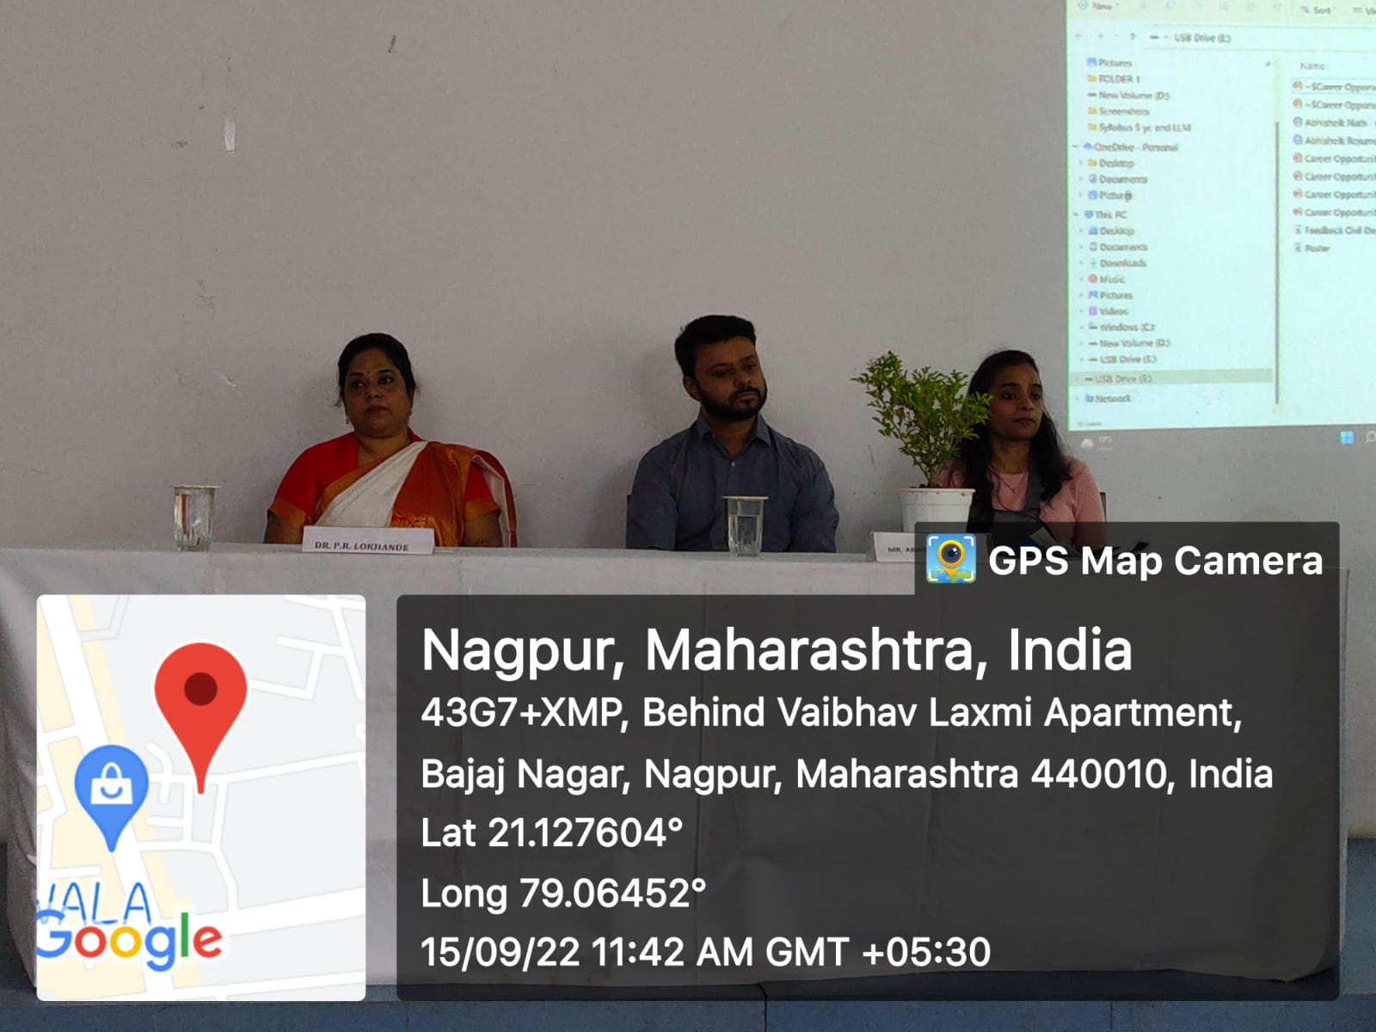
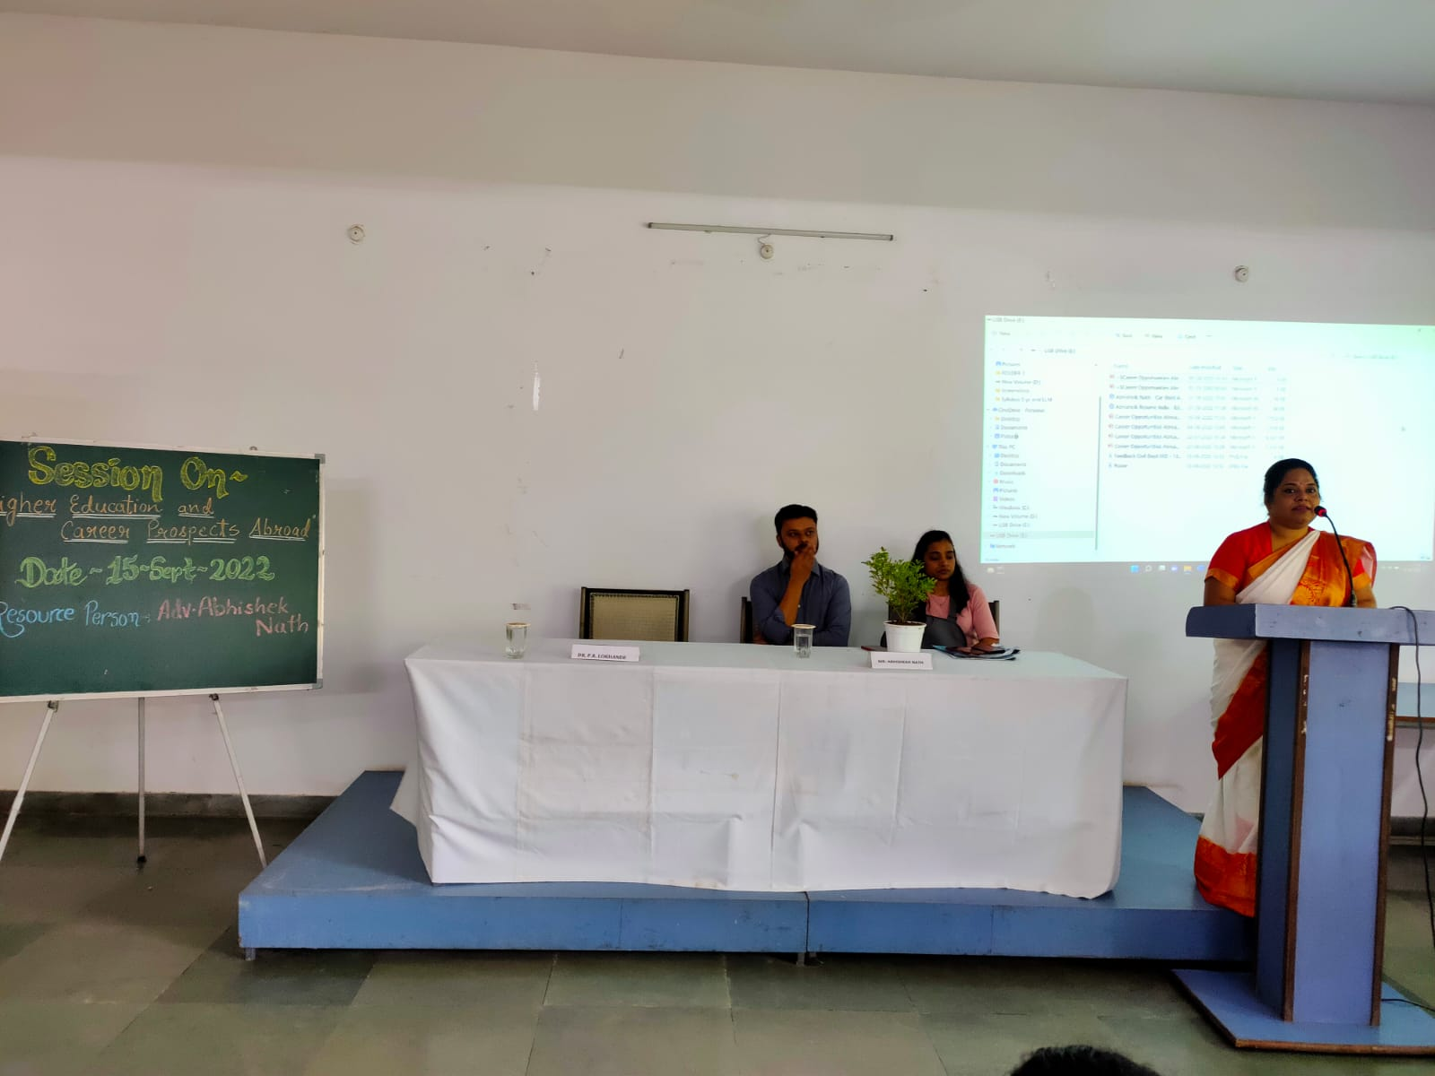
Introductory Remarks by Dr. Pratima Lokhande, Associate Professor
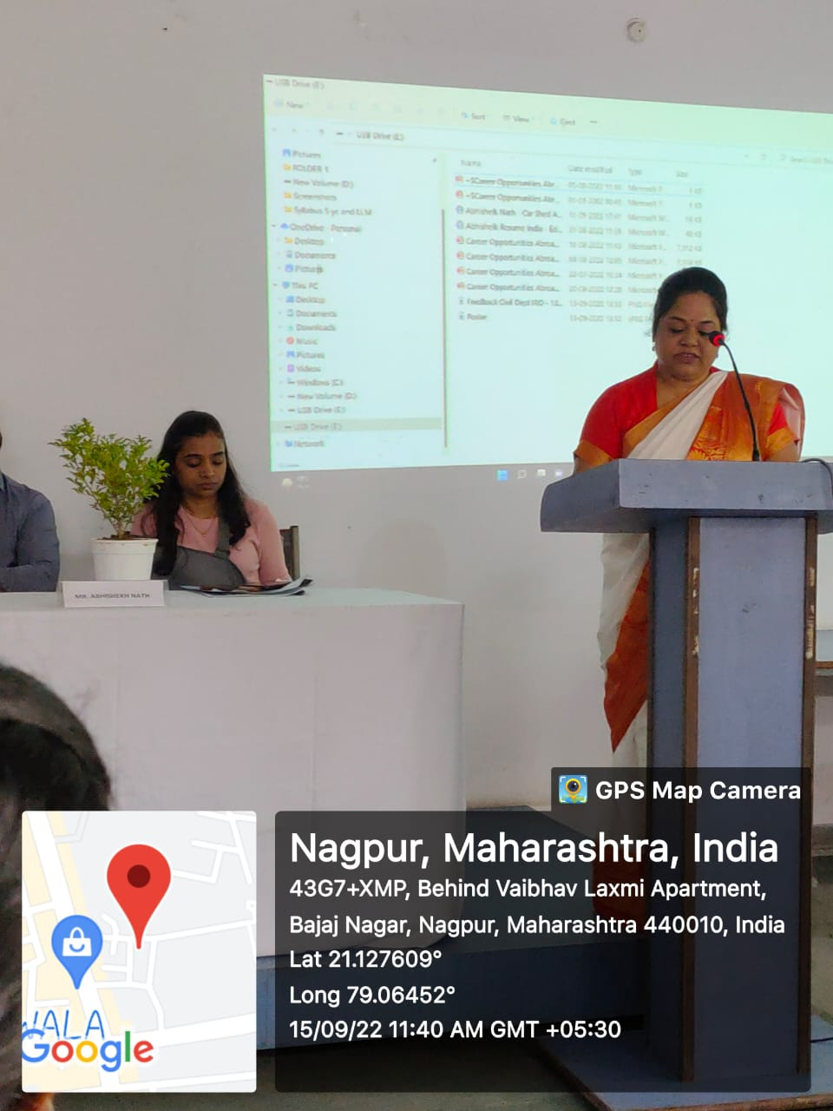
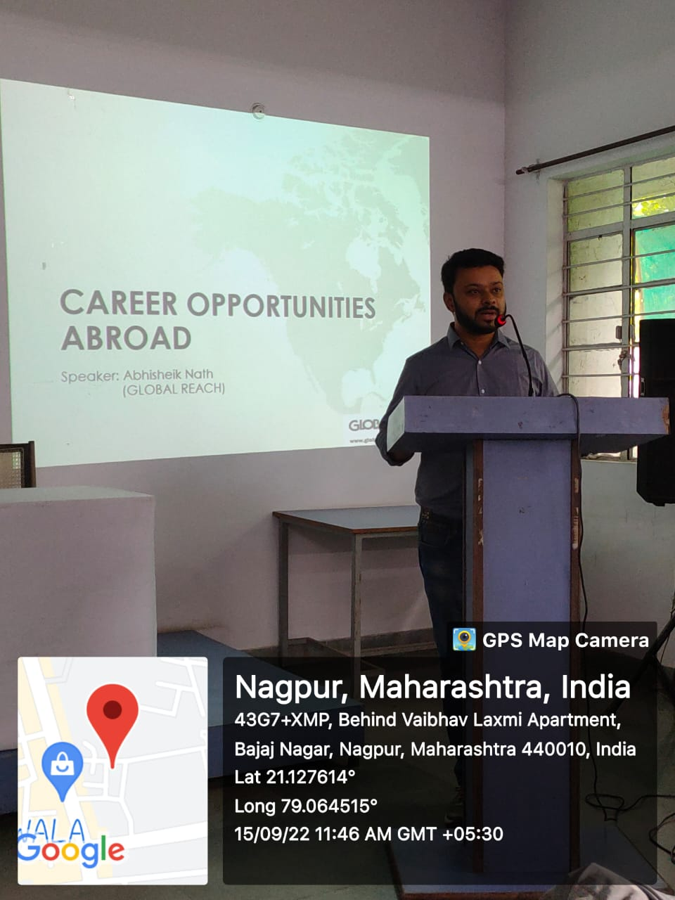MR. Abhishek Nath Addressing the Students, Senior counsellor
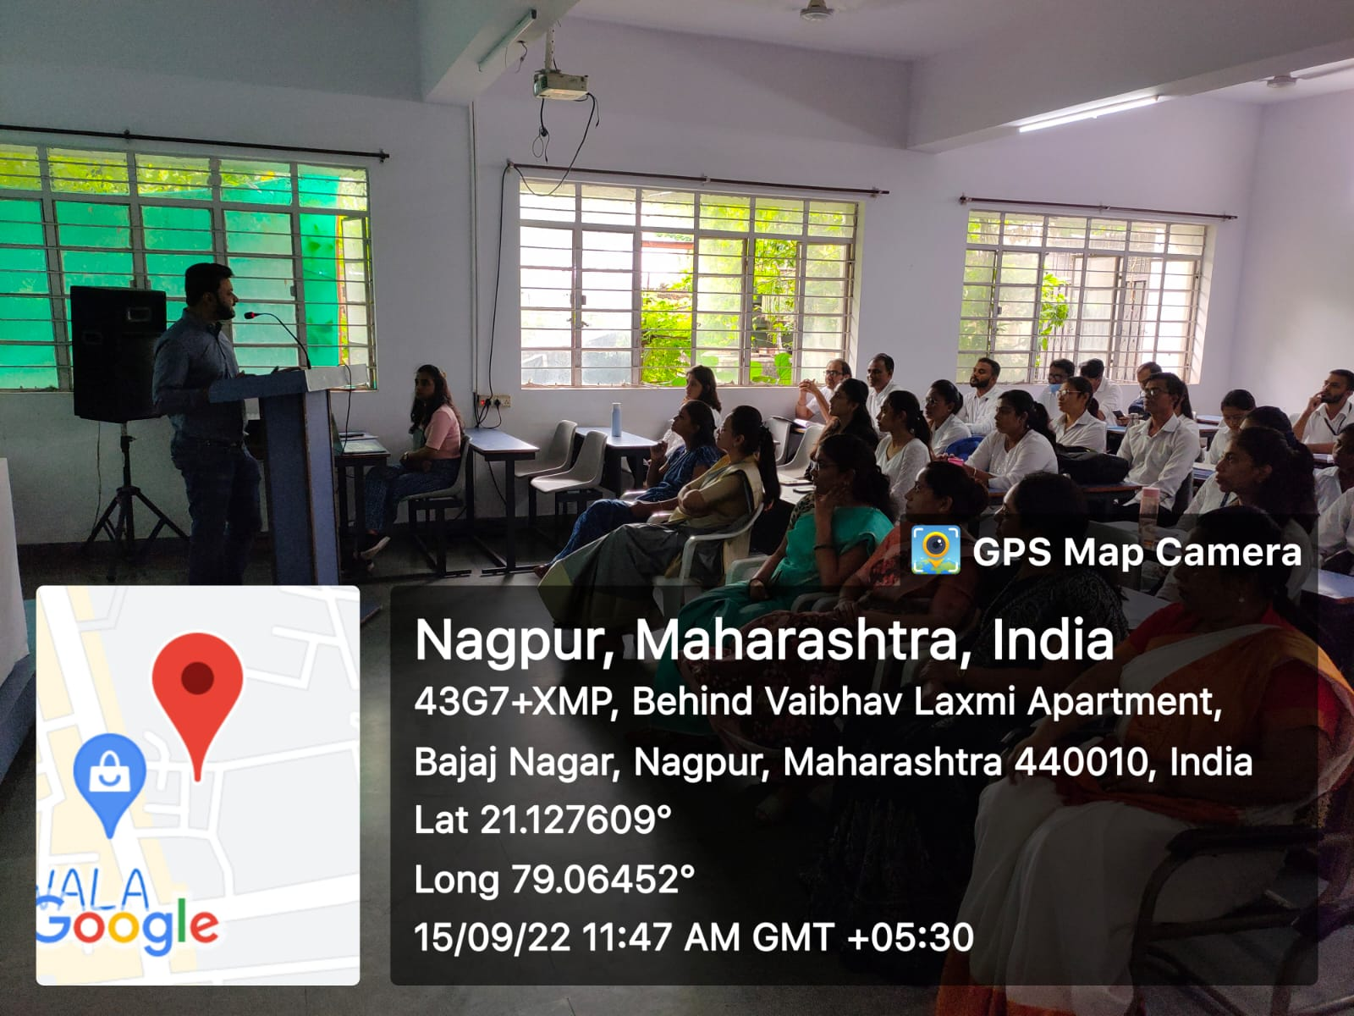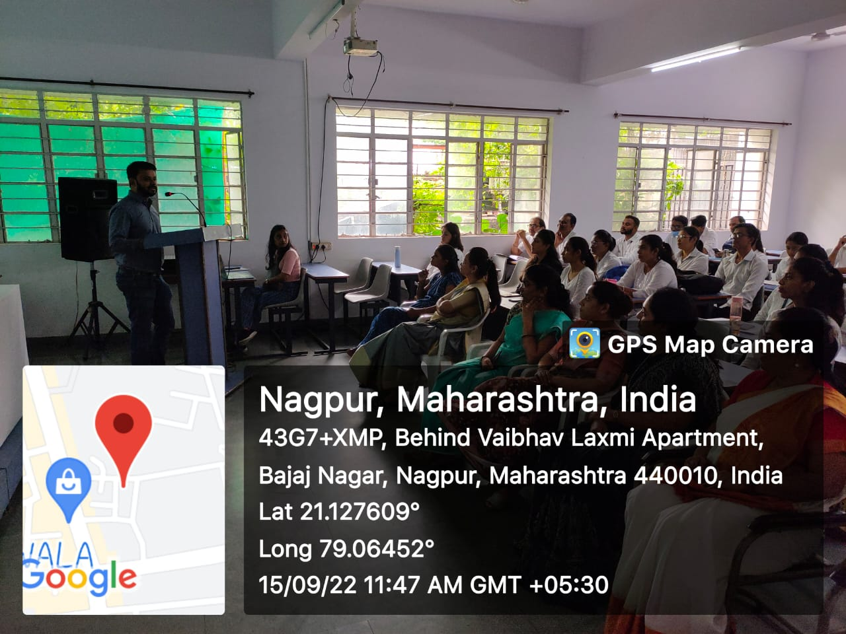
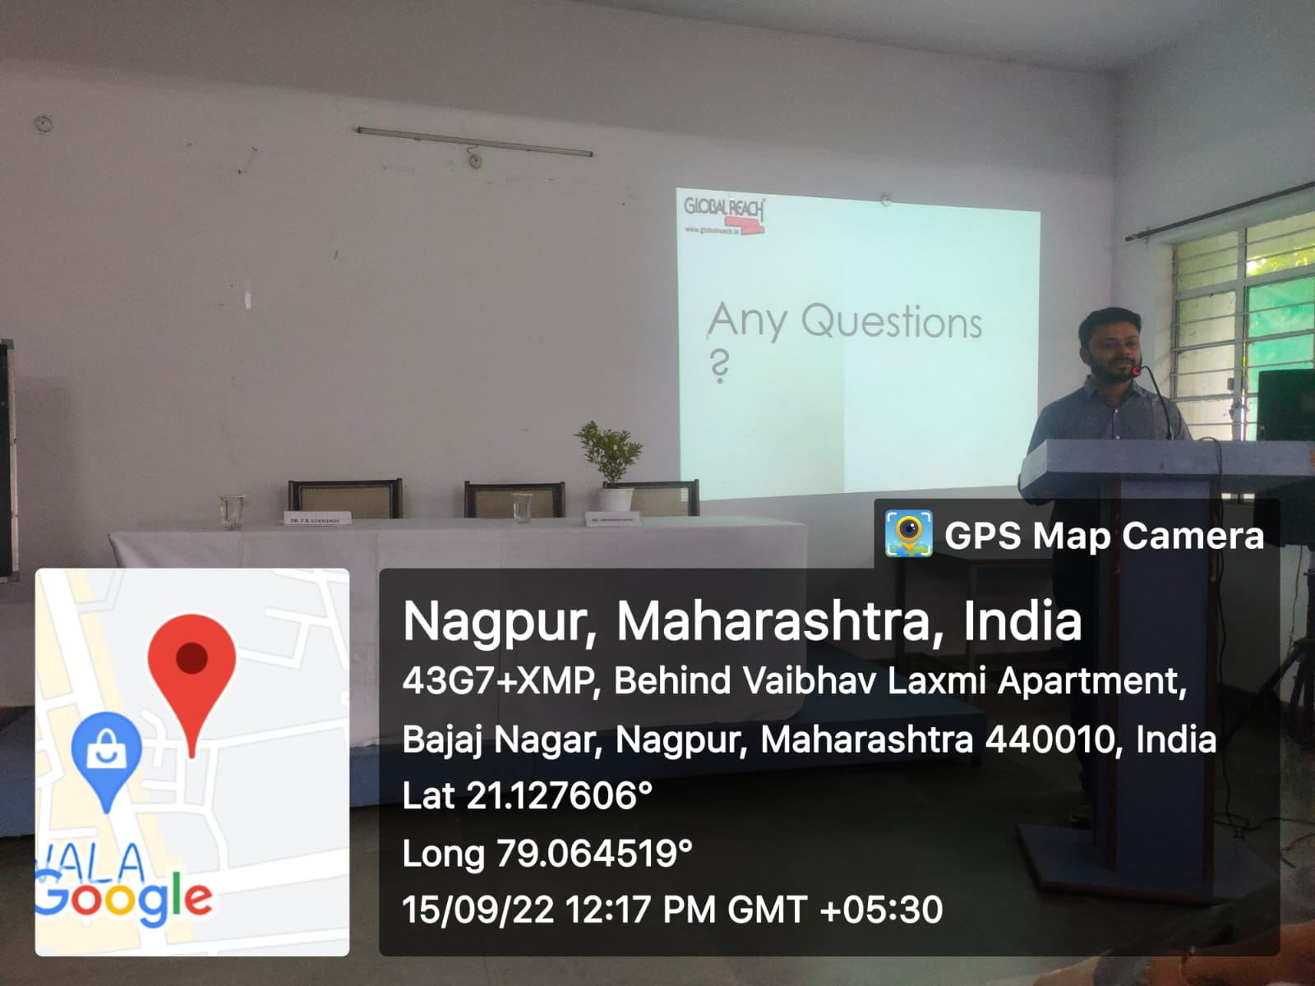
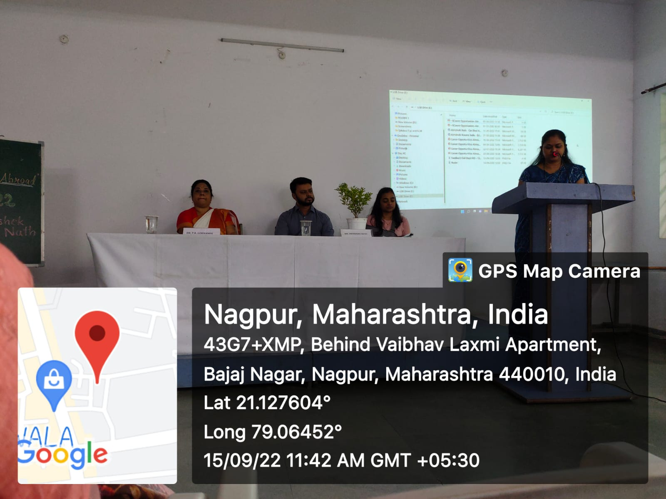Mrs. Vaishali Sukhdeve, Asst. Professor Proposing Vote of Thanks
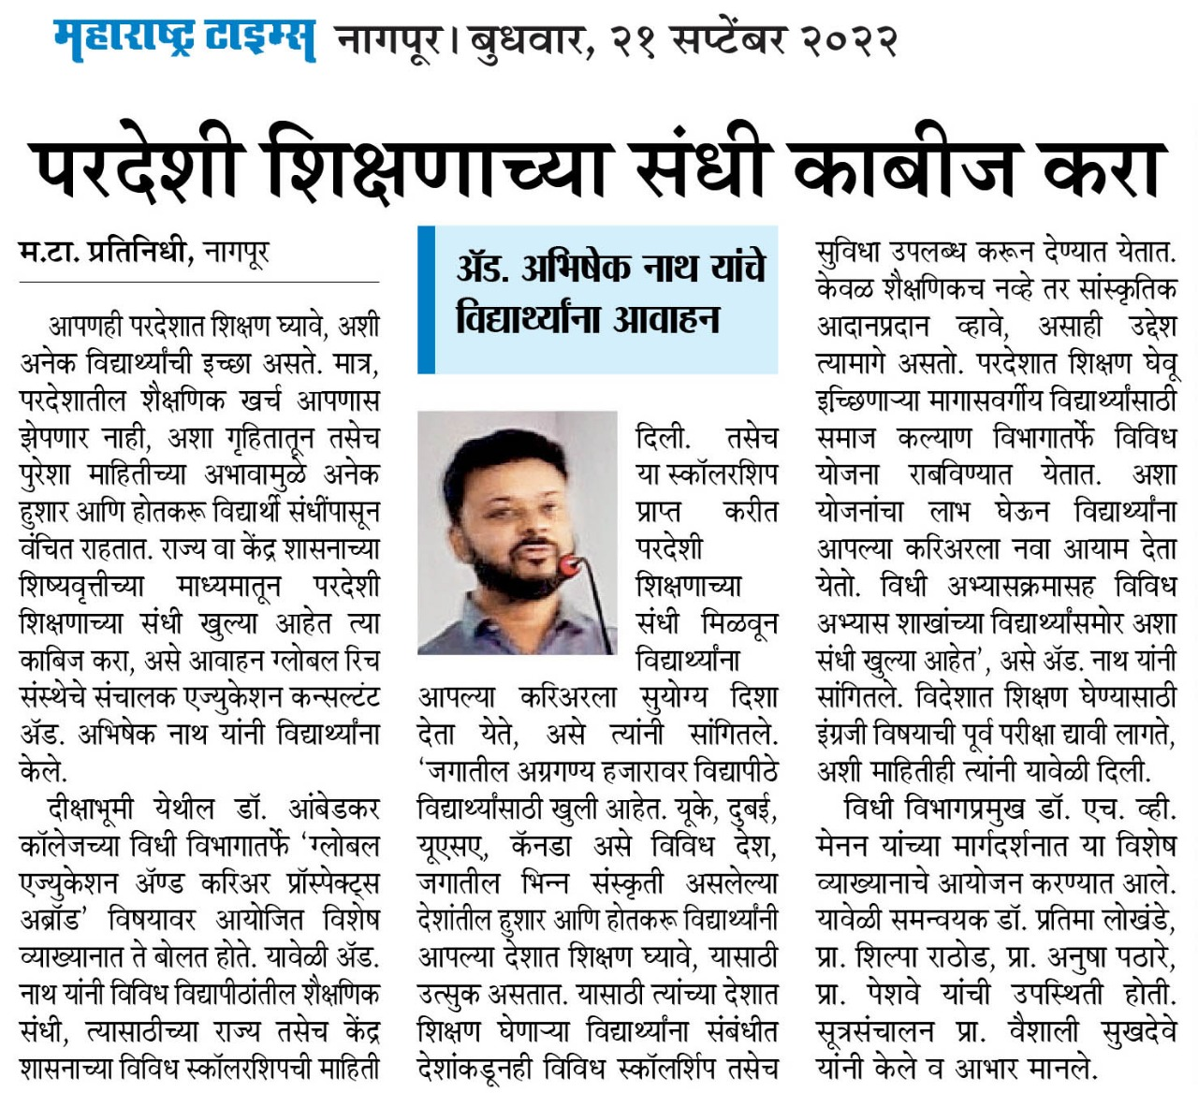
Newspaper Coverage
THREE DAYS FREE LEGAL AID AND LEGAL LITERACY PROGRAMME
Date: 3RD, 4TH & 5TH October 2022
Name of the Programme: FREE LEGAL AID AND LEGAL LITERACY PROGRAMME
Chief Guest: Hon’ble Shri S. B. Gawande
District Judge, District Court, Nagpur
Guest of Honour: Shri Jaideep Pandey
Organised by: Legal Aid Clinic of Department of Law
Co-ordinator of Legal Aid Clinic: Dr. Pratima Lokhande
Members of legal Aid Clinic: 1. Ms. Shilpa Rathod
2. Mrs. Vaishali Sukhdeve
3. Ms. Sarika Kamdi
Number of Volunteers: 124
Name of Venue: Department of Law, Dr. Ambedkar College Deeksha Bhoomi, Nagpur

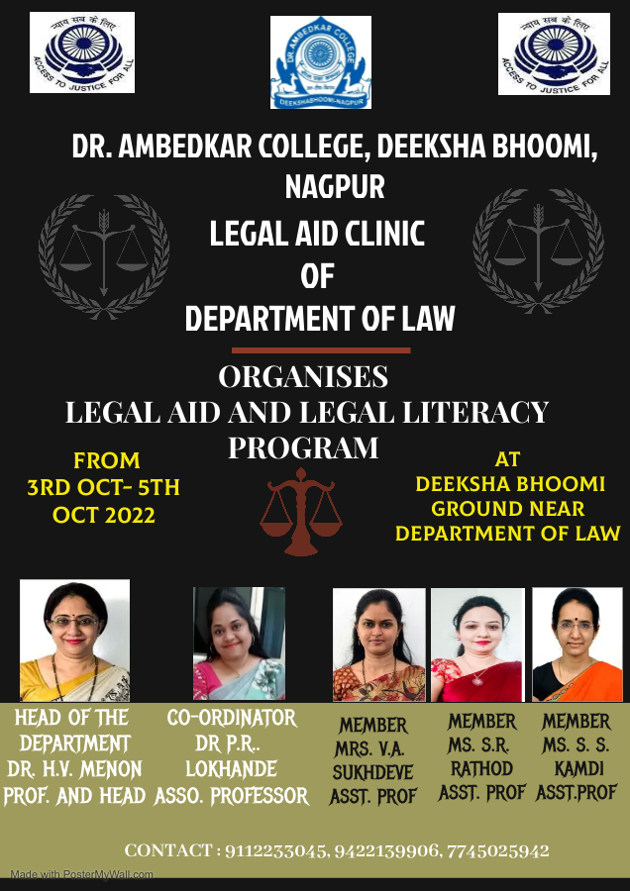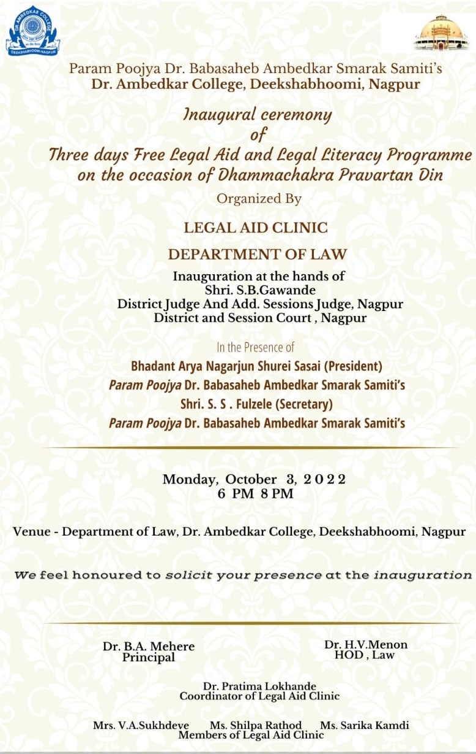
Three days Free Legal Aid and Legal Literacy Programme was inaugurated on 3rd October, 2022 at the hands of Chief Guest Hon’ble Shri S.B. Gawande District Judge & Additional Session Judge, District Court Nagpur in presence of Guest of Honour Shri Jaideep Pandey Secretary, DLSA Nagpur and Members of Param Poojya Dr Ambedkar Smarak Samiti Adv. Shri Anand Fulzele, Shri N. R Sute and Shri Pradeep Aglawe to mark the 66th Dhammachakra Pravartan Din in the Deeksha Bhoomi organized by the Legal Aid Clinic of Department of Law, Dr. Ambedkar College, Deeksha Bhoomi, Nagpur. Free Legal Aid and Literacy Programme is regularly organized since last 18 years by the Department of Law. This year, Department of Law has undertaken an initiative of conducting a survey about legal rights awareness and maintaining the record of complaints stated by the pilgrims who visit holy Deekshabhoomi. Complaint register was maintained by the student members of Legal Aid Clinic for further redressal. A special issue of Information brochure (Booklet) has been prepared by the coordinator and members of Legal Aid Clinic. Information Brochure was released at the hands of Chief Guest with an intent to spread an awareness about various laws and issues like health, free and compulsory education, welfare of women, senior citizens laws, Cyber offences and sexual offences against children. In addition to this, the Legal Aid clinic has also organised the Poster Making Competition which was based on 10 different themes. This competition received the overwhelming response from the students of LLB and LLM Course. Around 30 students have prepared the unique posters based on the given themes which has been displayed and inaugurated on the first day of Free Legal Aid and Legal Literacy Programme at the hands of Chief Guest and in presence of other invitees.
The program commenced with the garlanding of portraits of Tathagata Gautam Buddha and Parampoojya Dr. B.R. Ambedkar and lamp lighting ceremony at the hands of hon’ble guests of the Programme. Welcome address was given by Dr. Bhoomi Mehere Principal of the college to the well acclaimed Judges, the faculty members of the departments, treasured invitees and the participants. Dr. Hema Menon gave brief information regarding department of law. Dr. Pratima Lokhande gave the overview of the Legal Aid Clinic of Department of law.
Shri Jaideep Pandey Secretory of DLSA, Nagpur emphasized on making legal remedy more accessible to all so as to create a society as envisioned by the Constitution makers. He explained the role of DLSA in providing the free access to get the justice among the common masses who cannot afford the lawyers to get relief.
The Chief Guest Hon’ble Shri S.B. Gawande highlighted the importance of legal aid as an instrument to impart justice to poor masses. He informed the audience about Hussena Khatun v. State of Bihar case as a landmark case of fast-track trial. He further emphasised on the provisions of Legal Aid under Section 303 of the Code of Criminal Procedure (CrPC) and Sections 3 and 7 of the Code of Civil Procedure (CPC). He empathetically mentioned that while appealing to raise their voice for their just rights in the changing times, he also expressed hope that the law students should develop the quality of social service and strive to bring justice to the deprived and marginalized sections. He appreciated the efforts taken by the Department of Law and appealed law students and budding lawyers to pay back their Social Debt as a member of this society. He also emphasized on Reversal Parental Responsibility and remaining connected to one’s roots and culture.
One of the remarkable moments of the program was the skit presented by the Students of the Department of Law depicting how the present society still faces the offences of sexual abuse, domestic violence, unequal wages, denial of woman right in the property and the problems of age-old people in the society.
The Programme was conducted by Miss Anmol Shahu a student member from LLB III Sem 5 Years Course under the guidance & supervision of Co-ordinator and members of Legal Aid Clinic, Department of law.
The event concluded with vote of thanks proposed by Dr. Pratima Lokhande Co-ordinator of Legal Aid Clinic to the jury members and also to everyone who were present to witness the event.
Faculty members Dr. Varsha Deshpande, Dr. Mrs. Sandhya Kalamdhad, Ms. Shazia Bari, Mrs. Aishwarya Peshwe, Ms Anusha Patre and other staff members were prominently present. The programme was concluded on 5th October 2022 and proved to be a grand success and it was an enriching experience for students.

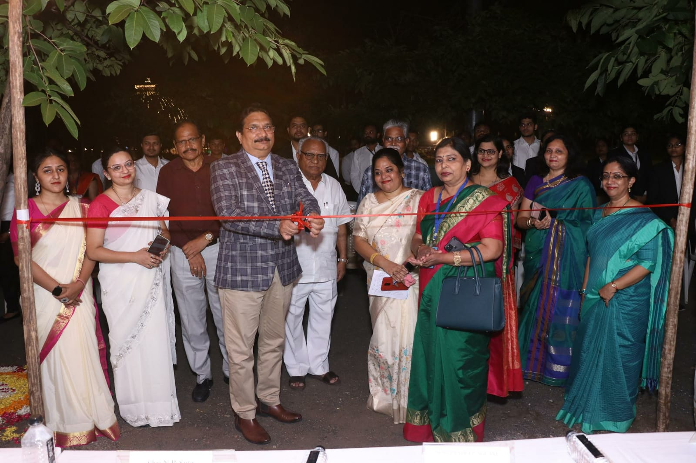
(Inauguration of Three days Free Legal Aid and legal Literacy Programme at the hands of Hon’ble District Judge Shri S.B. Gawande)
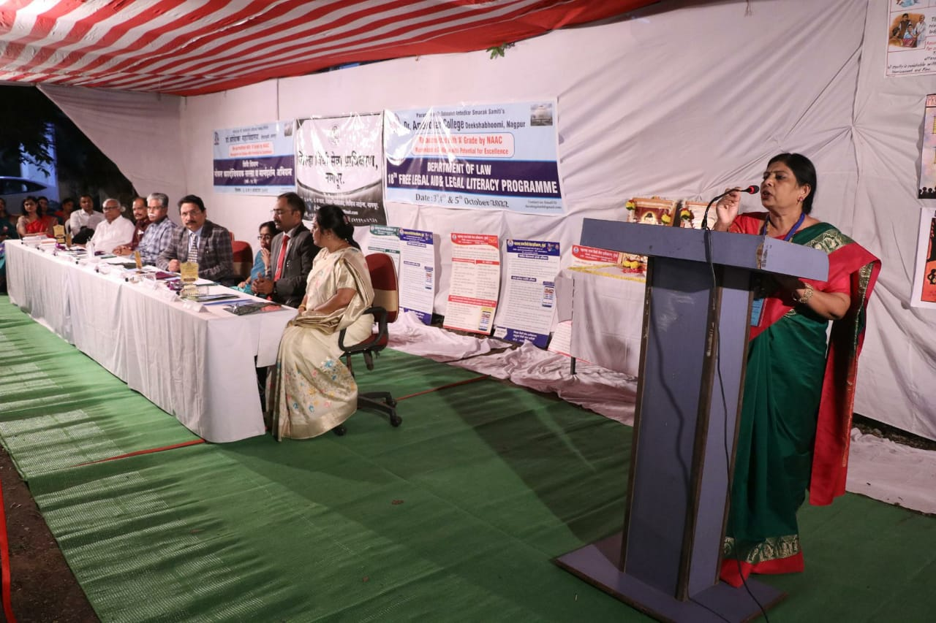
(Welcome Address by Dr. B. A. Mehere Principal of the college)
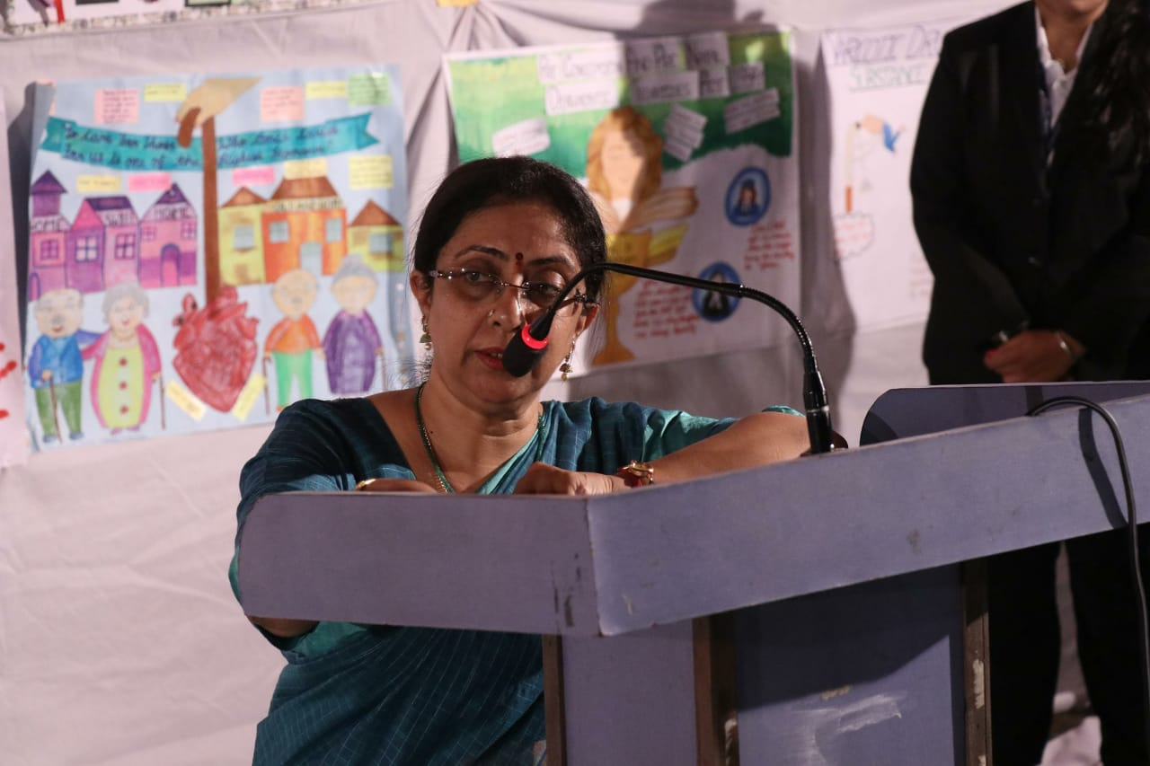
(Introduction of Department of Law by Dr. H.V. Menon Professor and Head Department of Law)
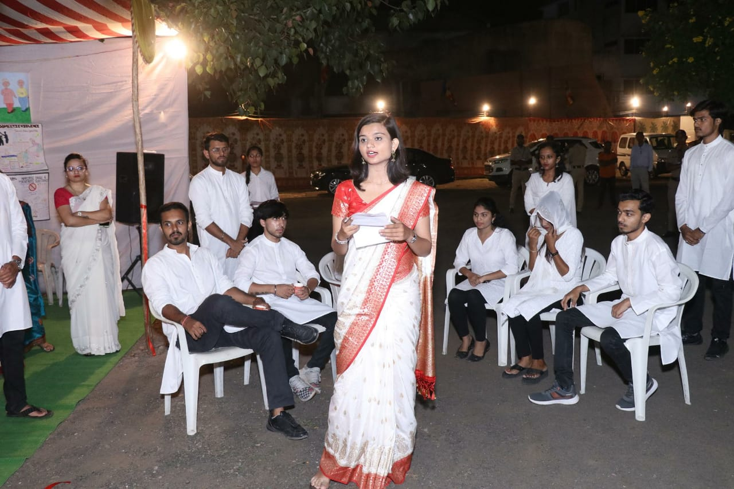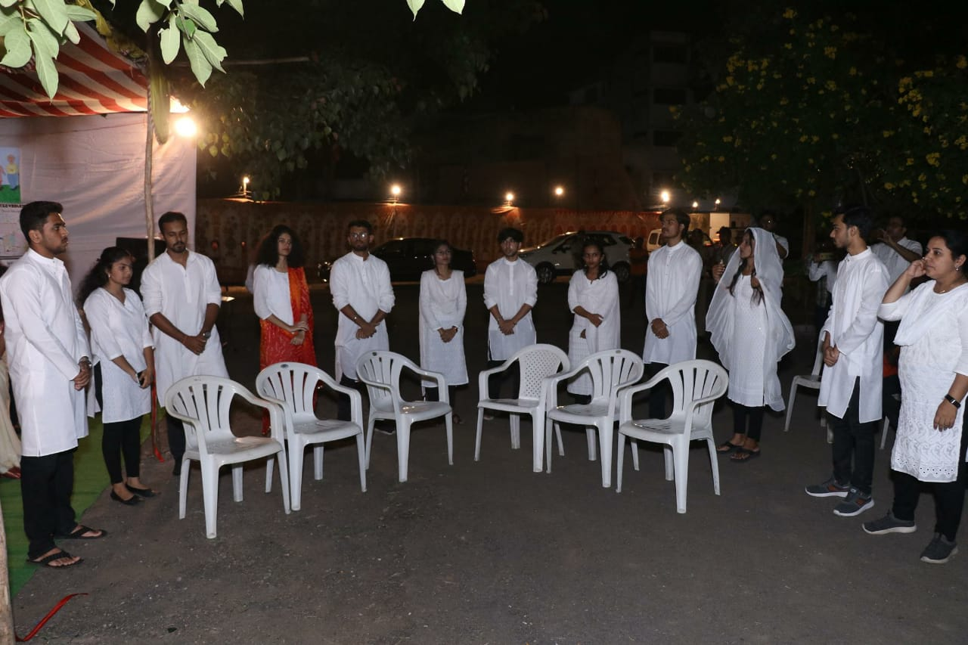
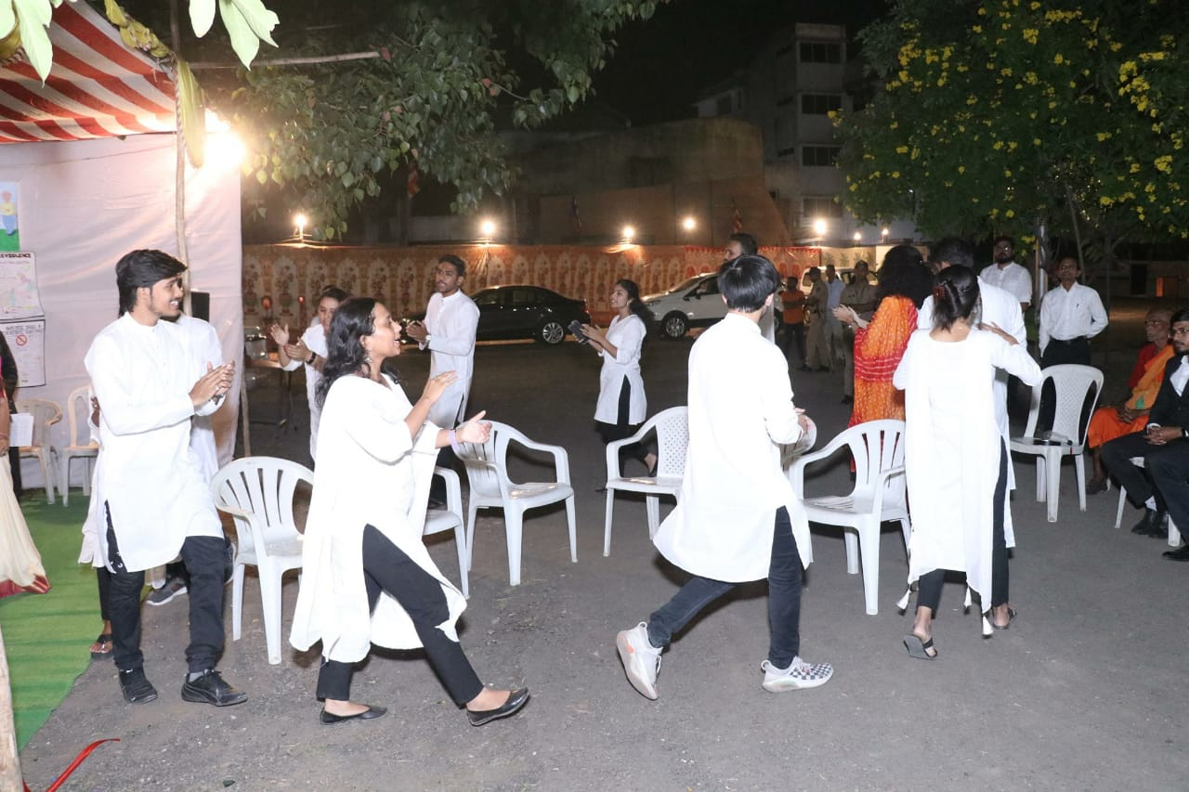(Skit played by the Students of Department)
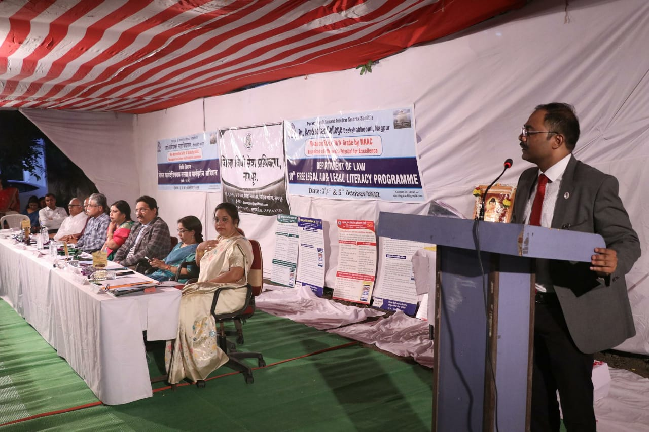
(Shri Jaideep Pandye introducing the role of District Legal Services Authority, Nagpur)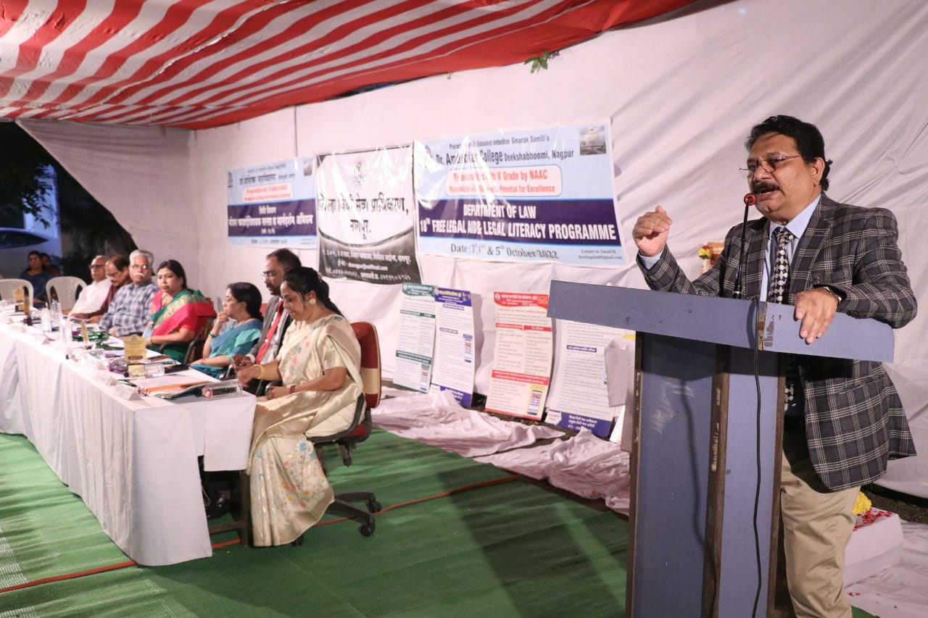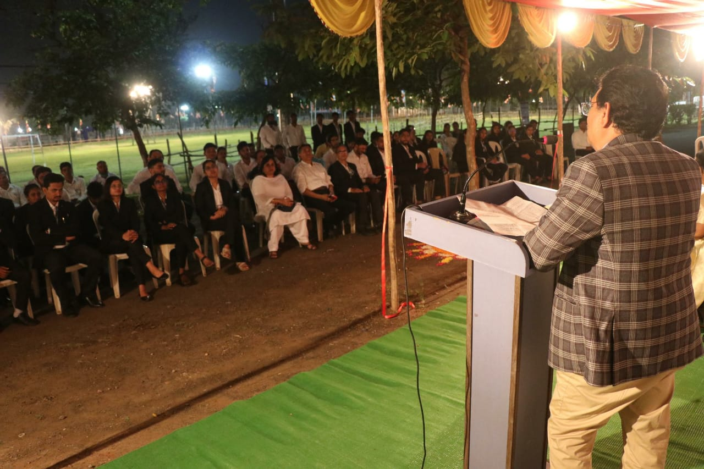(Hon’ble District Judge Shri S.B. Gawande giving the presidential remark to the audience present in the programme)
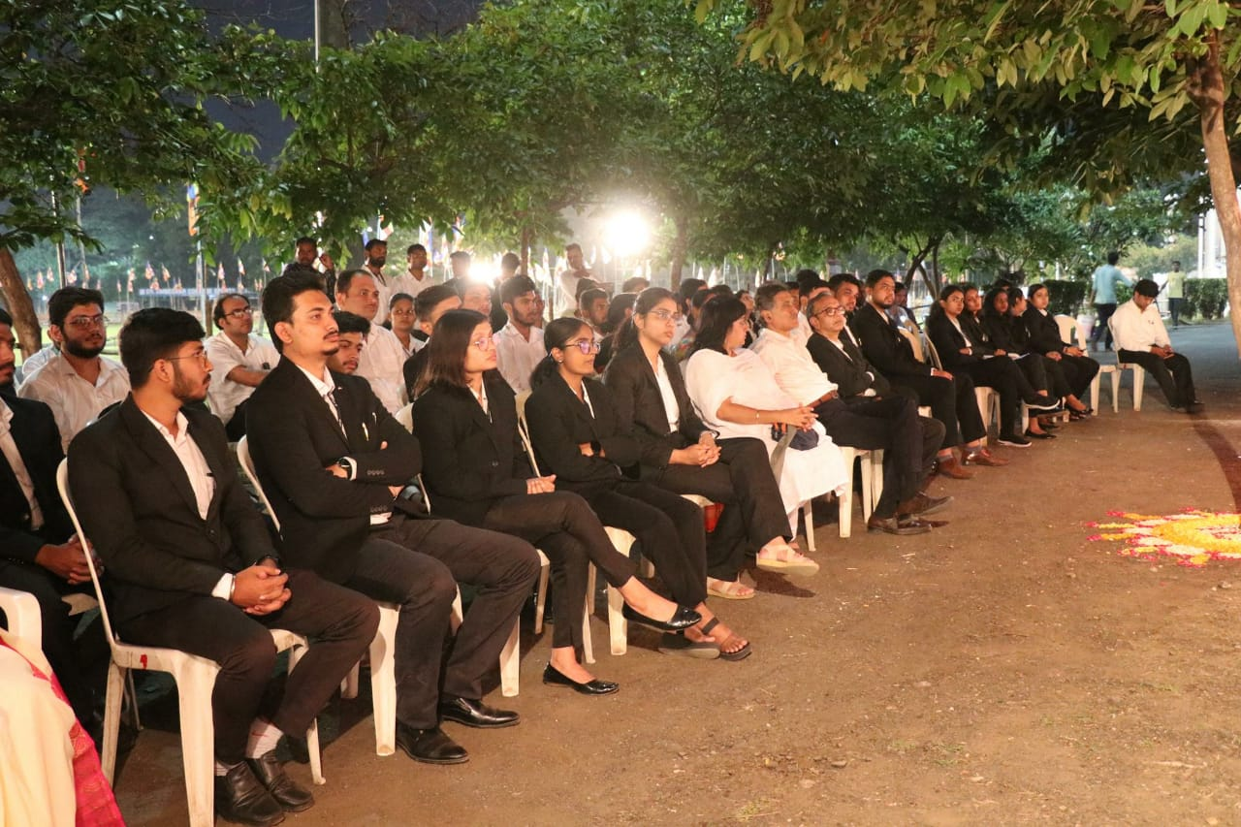
(Audience present in the programme and the poster display of all the participants)
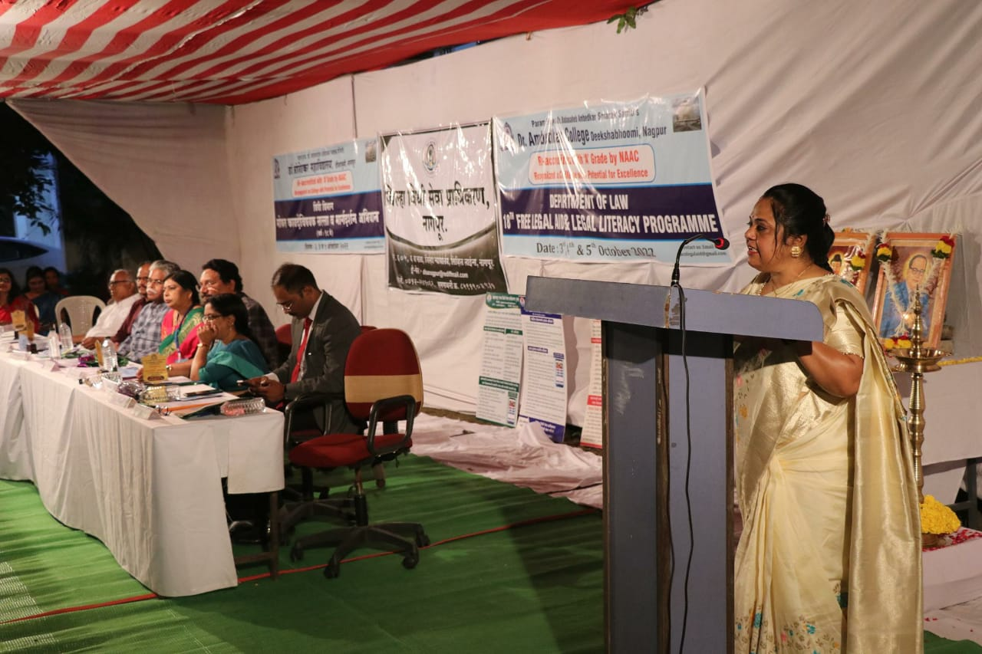
(Dr. P.R. Lokhande, Coordinator of Legal Aid Clinic, proposing Vote of Thanks)
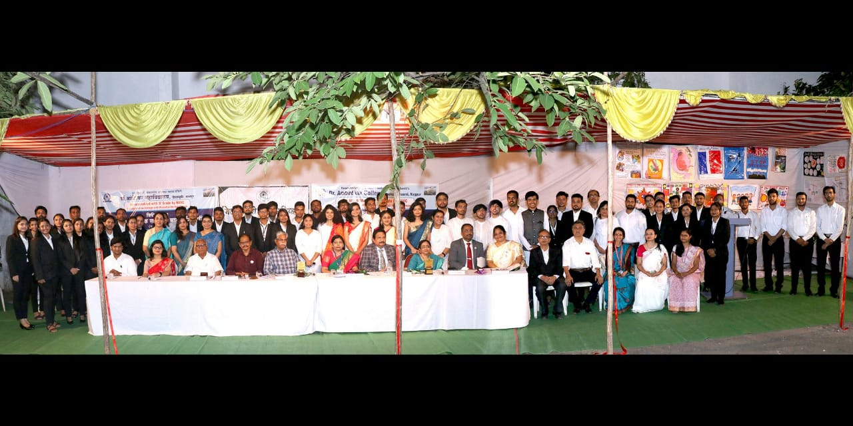
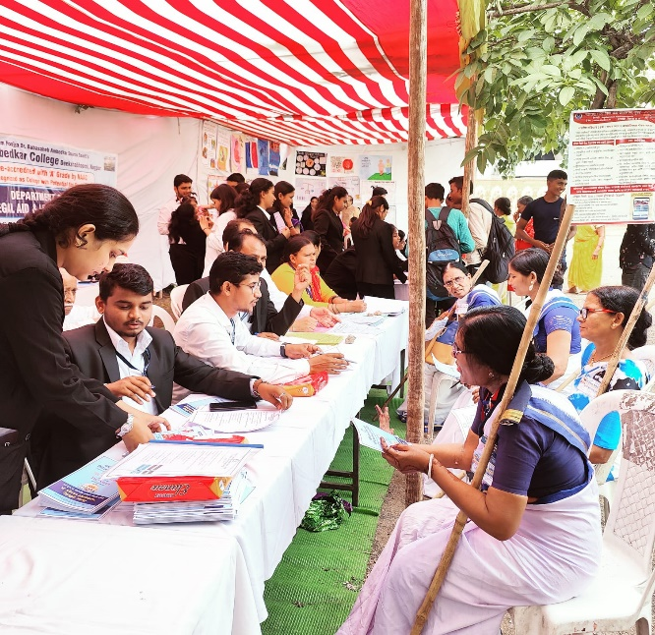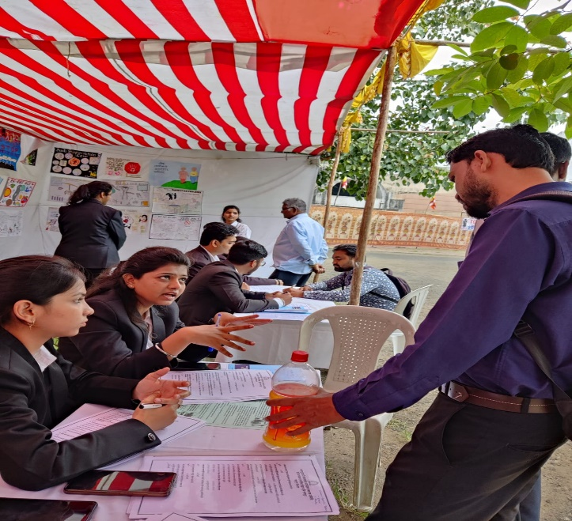
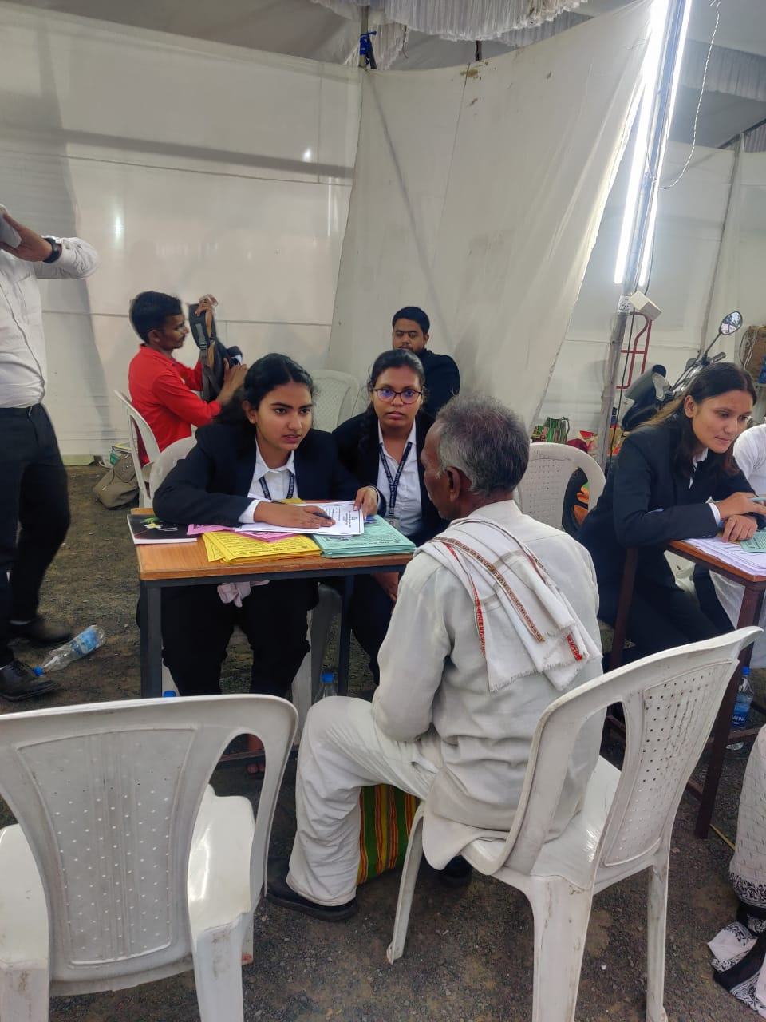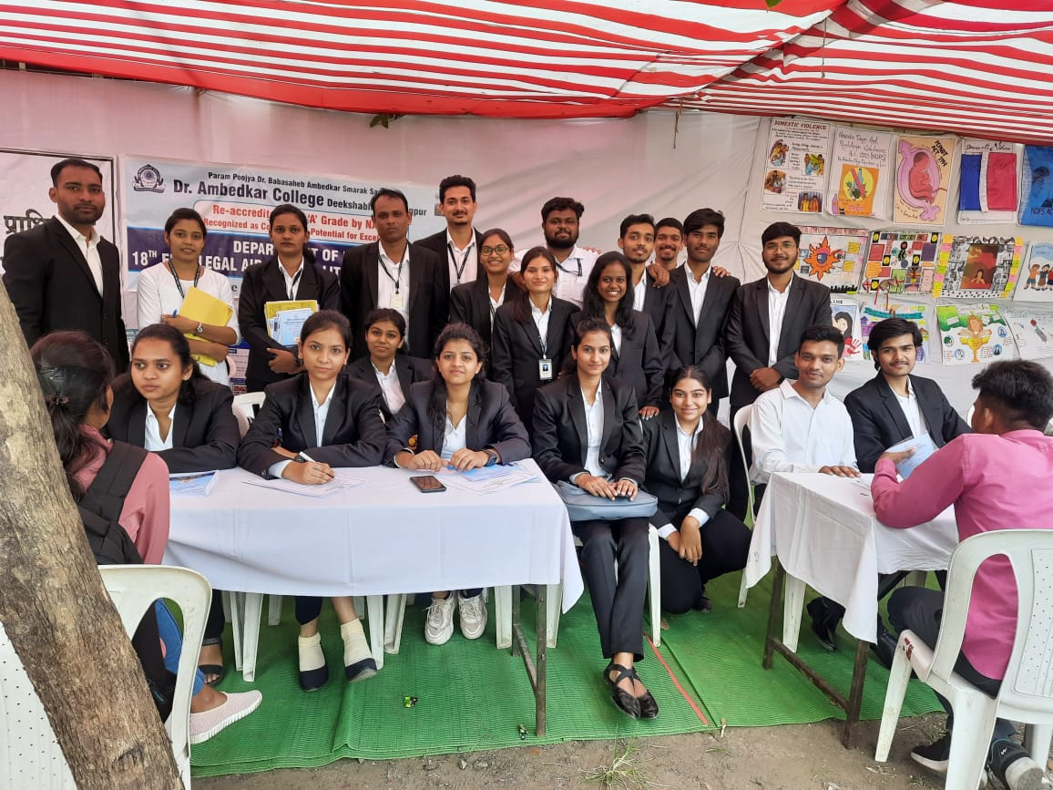
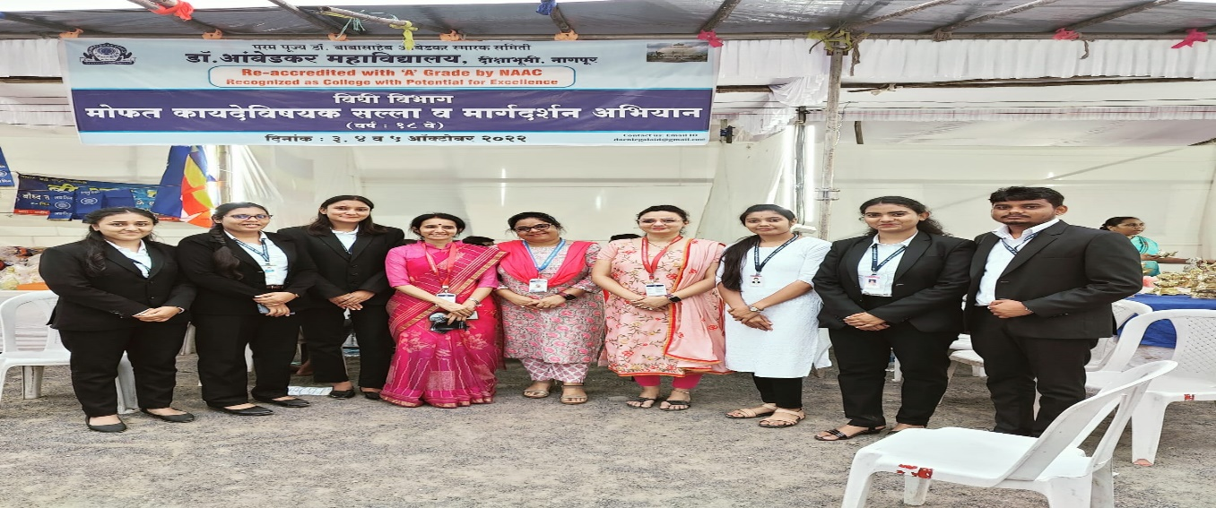
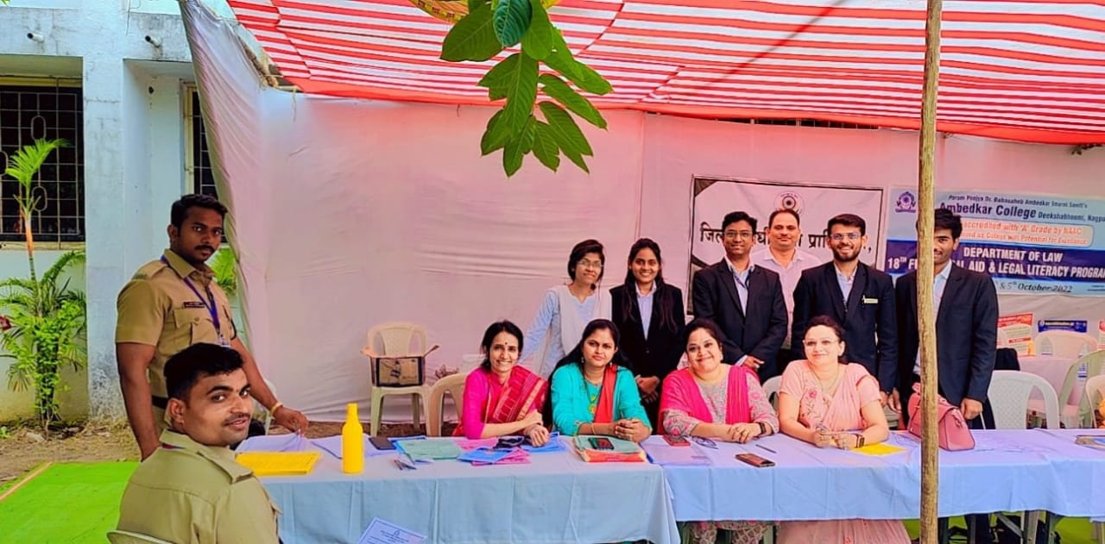
(Students and Faculty of the Department of Law providing Free Legal Aid to the Pilgrims and Distributing Information Booklet)
List of Volunteers for Three Days Legal Aid and Legal Literacy Programme